
DG MARKT
Framework Contract No DI/6769-2
Specific Contract No 010459

Digital Signature Services Post-Implementation
Functional Analysis
Functional Analysis Document



Subject | Functional Analysis
Version | 2.01
Release Date | 26/09/2013
Filename | 0000.doc
Document Reference | DSS4-FAD

Document History

Document History
Version | Release Date | Author | Description
0.01 | 11/02/2011 | Julien Stouffs | Version sent for Review
0.02 | 11/03/2011 | Julien Stouffs | Version sent for Acceptance
0.03 | 22/03/2011 | Julien Stouffs | Updated according to post-delivery comments;  Version sent for Acceptance 2
0.04 | 19/04/2011 | Julien Stouffs | Updated according to post-acceptance comments
0.90 | 30/06/2011 | Julien Stouffs | Version sent for Review
1.00 | 27/07/2011 | Christian Hiedels | Version sent for Acceptance
1.01 | 06/01/2012 | David Naramski | Version sent for Review  Added the ASiC-S profile (section 5.4.7)
2.00 | 20/01/2012 | David Naramski | Version sent for Acceptance
2.01 | 26/09/2013 | Robert Bielecki | Updated according to QTM1 & QTM2 of sub-contract 010459

Reviews
Version | Release Date | Reviewer | Position
0.01 | 07/02/2011 | Olivier Barette | Project Director
0.01 | 08/02/2011 | Frank Meyer | Project Manager
0.02 | 09/03/2011 | Olivier Barette | Project Director
0.02 | 11/03/2011 | Frank Meyer | Project Manager
0.03 | 22/03/2011 | Frank Meyer | Project Manager
0.04 | 19/04/2011 | Frank Meyer | Project Manager
1.00 | 27/07/2011 | Frank Meyer | Project Manager
1.01 | 06/01/2012 | Frank Meyer | Project Manager
2.00 | 20/01/2012 | Frank Meyer | Project Manager
2.01 | 26/09/2013 | Yannick Vincent | Project Manager

Table Of Contents

1 Introduction 9
1.1 Purpose of the Document 9
1.2 Intended Audience 9
1.3 Structure of the Document 9
2 Business Process Model 10
2.1 Trusted list business processes 10
2.1.1 Create /Edit a trusted list 11
2.1.2 Add service history 13
2.1.3 Add service information extension 14
2.1.4 Change the TSP of a service 15
2.2 DSS Applet business processes 16
2.2.1 Sign a document 16
2.2.2 Verify a signature 17
3 Use Case Model 19
3.1 Notation Overview 19
3.2 Actors 22
3.2.1 TSL User 22
3.2.2 DSS User 22
3.2.3 External User 23
3.3 Use Case Model 23
3.3.1 TSL Editing use cases 23
3.3.2 TSL Management use cases 33
3.3.3 DSS Web use cases 37
3.3.4 DSS Webservice use cases 42
4 Analysis Model 48
4.1 Notation overview 48
4.1.1 Entity diagram 48
4.1.2 State diagram 49
4.2 Entities and Business Rules 50
4.2.1 Trusted list entities 51
4.2.2 DSS web entities 61
4.3 User interfaces 62
4.3.1 Trusted List user interfaces 62
5 Supplementary Specifications 72
5.1 Packaging method 72
5.2 LOTL management 72
5.3 List generation 73
5.3.1 Trusted list configuration file 73
5.3.2 LOTL configuration file 75
5.3.3 TSL signature 75
5.4 DSS Web profiles 78
5.4.1 Compliance requirements 78
5.4.2 Configuration file 78
5.4.3 Multiple signature 79
5.4.4 XAdES profile 79
5.4.5 CAdES profile 83
5.4.6 PAdES profile 86
5.4.7 ASiC profile 88
5.5 Validation algorithm 88
5.5.1 Description 89
5.5.2 Validation Constraints and Validation policy 99
5.6 Usability 101
5.6.1 Accessibility 101
5.6.2 Internationalisation 101
5.7 Availability 101
5.8 Performance 101
5.9 Security 101
5.10 Supportability 101
5.10.1 Java runtime environment 101
5.10.2 PKCS#11 Middleware 101
5.10.3 Browser 101
5.11 Documentation Requirements 102
5.11.1 User manual 102
5.12 Legal, Copyright and Other Notices 102
5.12.1 License 102
5.12.2 Source code publishing 102
5.12.3 What you see is what you sign paradigm 102
5.13 Frequently asked questions 102

List of Tables

Table 1: Reference Documents 7
Table 2: Applicable Documents 7
Table 3: Abbreviations and Acronyms 8
Table 4: Example of certificate content analysis report format 97
Table 5: Final conclusion matrix 98

List of Figures

Figure 1: Business Process – Create a new trusted list 11
Figure 2: Business process - Add service history 13
Figure 3: Business process - Add service information extension 14
Figure 4: Business process - Change the TSP of a service 15
Figure 5: Business process - Sign a document 16
Figure 6: Business process - Verify a document 17
Figure 7: Notation for an actor 19
Figure 8: Notation for a Use Case 19
Figure 9: Notation to associate an actor with a Use Case 20
Figure 10: Use Case Inclusion 20
Figure 11: Use Case Extension 21
Figure 12: Actors 22
Figure 13: TSL editing use case diagram 23
Figure 14: TSL Management use case diagram 33
Figure 15: DSS use cases diagram 37
Figure 16: DSS WS use cases diagram 42
Figure 17: Notation for an Entity 48
Figure 18: Notation for an Aggregation 48
Figure 19: Notation for a Composition 48
Figure 20: Notation for Inheritance 49
Figure 21: Notation for a State 49
Figure 22: Notation for a Transition 49
Figure 23: Trusted list entities 51
Figure 24: DSS web entities 61
Figure 25: Trusted list signature 77
Figure 26: Certification path and revocation data analysis 90
Figure 27: Trusted list analysis 95
Figure 28: Certificate content analysis 96

Reference and Applicable Documents
This section contains the lists of all reference and applicable documents. When referring to any of the documents below, the bracketed reference will be used in the text, such as [R01].

Reference Documents
Ref. | Title | Reference | Version | Date
R01 | Study on Cross-Border Interoperability of eSignatures | CROBIES - WP2-1 | 2.1 | 31/07/2010
R02 | Commission Decision of 28 July 2010 | CD 2010/425/EU | 1.0 | 31/07/2010
R03 | Xml Advanced Electronic Signatures (XAdES) | ETSI TS 101 903 | 1.4.2 | 12/2010
R04 | Electronic Signatures and Infrastructures; Profiles on XML Advances Electronic Signatures based on TS 101 903 (XAdES) | ETSI TS 102 904 | 1.1.1 | 02/2007
R05 | Electronic Signatures and Infrastructures; Profiles on CMS Advances Electronic Signatures based on TS 101 733 (CAdES) | ETSI 102 734 | 1.1.1 | 02/2007
R06 | Commission Decision of 25 February 2011 | CD 2011/130/EU | 1.0 | 26/02/2011
R07 | CMS Advanced Electronic Signatures (CAdES) | ETSI TS 101 733 | 1.8.3 | 01/2011
R08 | Document management – Portable Document Format – part 1: PDF 1.7 | ISO 32000-1 | 1.7 | 2008
R09 | Electronic Signatures and Infrastructures (ESI); Associated Containers (ASiC) | ETSI TS 102 918 | 1.1.1 | 04/2011
R10 | The Rational Unified Process at the European Commission | RUP@EC | 2.1 | 13/06/2006
R11 | ETSI – Electronic Signatures and Infrastructure (ESI); Provision of harmonized Trust-service status information | ETSI TS 102 231 | 3.1.2 | 12/2009
R12 | Electronic Signatures and Infrastructures (ESI); XAdES Baseline Profile | RTS/ESI-000103 | N/A | N/A
R13 | Electronic Signatures and Infrastructures (ESI); PAdES Baseline Profile | RTS/ESI-000104 | N/A | N/A
R14 | Electronic Signatures and Infrastructures (ESI); CAdES Baseline Profile | RTS/ESI-000105 | N/A | N/A
R15 | Electronic Signatures and Infrastructures (ESI); Associated Baseline Profile | RTS/ESI-000106 | N/A | N/A
R16 | Digital Signature Services  Technical Analysis  Frequently Asked Questions  Replaced by JOINUP: https://joinup.ec.europa.eu/software/sd-dss/home | DSS-FAQ-Frequently Asked Questions | 0.2 | 22/03/2011
R17 | Electronic Signatures and Infrastructures (ESI); PDF Advanced Electronic Signature Profiles (Multipart) | ETSI TS 102 778-1/6 | Multipart | 2009-2010
R18 | Signature Validation Policy & Report Simplification Analysis | DSS3-QTM4-SIGPOL | 1.00 | 23/04/2013
R19 | Electronic Signatures and Infrastructures;  Signature verification procedures and policies | ETSI TS 102 853 | 1.1.1 | 2012-07
R20 | Electronic Signatures and Infrastructures (ESI);  Trusted Lists | ETSI TS 119 612 | 1.1.1 | 2013-06
Table 1: Reference Documents

Applicable Documents
Ref. | Title | Reference | Version | Date
A01 | Framework Contract ESP DESIS II – Lot 2 | DI/6769-2 | N/A | 25/02/2011
A02 | Kick off meeting minutes | DSS-MOM-20110112 | 1.00 | 14/01/2011
A03 | Specific Contract | SC 4708 | N/A | 10/10/2011
A04 | “Quoted Time & Means” Form # 1 | QTM-T1 | N/A | 18/09/2013
A05 | “Quoted Time & Means” Form # 2 | QTM-T2 | N/A | 18/09/2013
Table 2: Applicable Documents

Abbreviations and Acronyms

Abbreviations and Acronyms
Abbreviation | Meaning
AdES | Advanced Electronic Signature
ASiC | Associated Signature Container
BES | Basic Electronic Signature
CA | Certificate Authority
CAdES | CMS Advanced Electronic Signatures
CMS | Cryptographic Message Syntax
CRL | Certificate Revocation List
CROBIES | Cross Border Interoperability of eSignatures
DSS | Digital Signing Service
EPES | Explicit Policy based Electronic Signature
ETSI | European Telecommunications Standards Institute
LGPL | Lesser General Public License
LOTL | List Of Trusted Lists
LTV | Long Term Validation
OCSP | On-Line Certificate Status Protocol
PAdES | PDF Advanced Electronic Signature
PDF | Portable Document Format
PKCS | Public Key Cryptography Standards
PKI | Public Key Infrastructure
PKIX | Internet X.509 Public Key Infrastructure
QC | Qualified Certificate
SIE | Service Information Extension
SSCD | Secure Signature Creation Device
TL | Trusted List
TSL | Trust service Status List
TSP | Trust Service Provider
URI | Uniform Resource Identifier
XAdES | XML Advanced Electronic Signature
XML | Extensible Markup Language
WS | Web service
WSDL | Web Services Description Language
WYSIWYS | What you see is what you sign
Table 3: Abbreviations and Acronyms

Introduction

Purpose of the Document
The purpose of this document is to collect, analyse, and define high-level needs and features of the Digital Signature Services system.
This document provides a description of the system specifications in terms of:
- Business Processes Model, provides the identification and description of the main Business Processes;
- Actors and Use Cases, a standard way to translate and organise the understanding of stakeholder needs into a meaningful description of the system to be built. The Use Case model references entities and interface specifications provided in the Analysis Model chapter;
- Supplementary Specifications, capturing system requirements that are not captured in behavioural requirements artefacts such as use case model.

Intended Audience
The present document is intended to be read by the following teams, but not limited to:
- DG MARKT Team;
- Development Team.

Structure of the Document
The document is organized as follows:
- Chapter 1 - Introduction summarises the purpose and scope of the document, and lists the intended audience.
- Chapter 2 - Business Process Model provides an overview of the main flows of activities defined for users of the application.
- Chapter 3 - Use Case Model describes the functionality supported by the application in the form of a Use Case Model.
- Chapter 4 - Analysis Model provides a description of the entities, business rules and system interfaces referenced in the different use cases of the Use Case Model.
- Chapter 5 - Supplementary Specifications lists technical requirements that are not captured in the Use Case Model.

Business Process Model
This section provides an overview of the main user scenarios that are described in detail throughout this document. The following main user scenarios are:
- Trusted List:
  - Create or update a trusted list.
  - Add service history.
  - Add service information extension.
  - Change the TSP of a service.
- DSS Web Applet:
  - Sign a document.
  - Verify a signature and produce a simple validation report.
  - Extend a signature.
  - Manage the validationpolicy.

Trusted list business processes
The program can be opened in different modes. Firstly it can be used to manage a simple trusted list (TSL) or to manage the list of the trusted lists (LOTL). Secondly it can be used in the context of a Member State of the European Union, or in the more open context of an organisation or a non-member country. The application behaviour is dictated by the set of parameters when launching the application.
NOTE 1: Following the publication of the new ETSI TS 119 612 specifications, please note that in order to manage the old format of the list (the one based on the ETSI TS 102 231 standard) the user must use the older version of TLManager based on the release 2.0.2 of the DSS framework.
NOTE 2: When opening a file containing a trusted list which is consistent with the old standard, the program automatically converts the data to comply with the new specification. The exception is made when a trusted service contains a digital identity based on the multiple certificates with different public keys. In this case the transformation is left to the user, it is impossible to sign the list as the correction is not made.

Create /Edit a trusted list
The following diagram presents the flow of activities that might occur while a user creates or edits a trusted list.
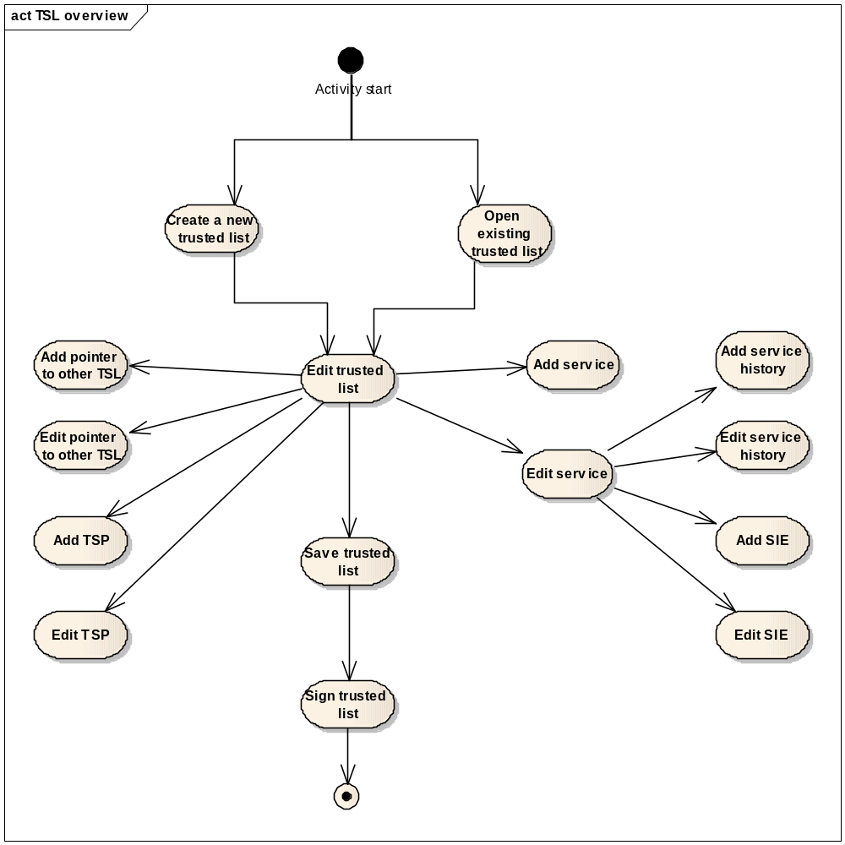
Figure 1: Business Process – Create a new trusted list
- The user can start from a new empty trusted list or update an existing trusted list.
- Once a trusted list has been created or opened, the user edits its information:
  - TSL id;
  - Scheme information.
- Pointer to other TSL is mandatory information that must be added to the trusted list used in the context of amember state. The trusted list must provide exactly 2 pointers to other TSL. This information is optional for non-member states or other organisations.
- The user can add one or more TSPs. A TSP is not mandatory, but if present it must be associated to at least one service.
- Each entry of a trusted list can be edited by the user, in particular:
  - Pointer to other TSL information;
  - TSP information;
  - Service information
- Service information can be completed by service information extension:
  - Qualification extension;
  - Additional service information extension;
  - Taken over by extension;
  - ExpiredCertsRevocationInfo extension.
- Service history information can be added to a service. This history information can have its own service information extensions and are independent of the service information.
- Finally, the user must save and sign the trusted list before publishing it. The system will check the trusted list during the signing activity. (Mandatory fields, business rules …).

The following table lists the corresponding use cases for each activity shown in the diagram above.
Create a new trusted list
Step | Actor | Realized by
Create a new trusted list | TSL User | UC-TSL 2.1 – Create a new TSL
Open existing trusted list | TSL User | UC-TSL 2.3 – Open a TSL
Edit trusted list | TSL User | UC-TSL 1.1 – Edit TSL entry
Add pointer to other TSL | TSL User | UC-TSL 1.2 – Add pointer to other TSL
Edit pointer to other TSL | TSL User | UC-TSL 1.1 – Edit TSL entry
Add TSP | TSL User | UC-TSL 1.3 – Add a TSP
Edit TSP | TSL User | UC-TSL 1.1 – Edit TSL entry
Add service | TSL User | UC-TSL 1.4 – Add a service
Edit service | TSL User | UC-TSL 1.1 – Edit TSL entry
Add service history | TSL User | UC-TSL 1.5 – Add a service history
Edit service history | TSL User | UC-TSL 1.1 – Edit TSL entry
Add SIE | TSL User | UC-TSL 1.6 – Add service information extension
Edit SIE | TSL User | UC-TSL 1.1 – Edit TSL entry
Save trusted list | TSL User | UC-TSL 2.2 – Save a TSL
Sign trusted list | TSL User | UC-TSL 2.4 – Sign a TSL

Add service history
The following diagram presents the flow of activities that might occur while a user modifies service’s information and creates a new service history entry.
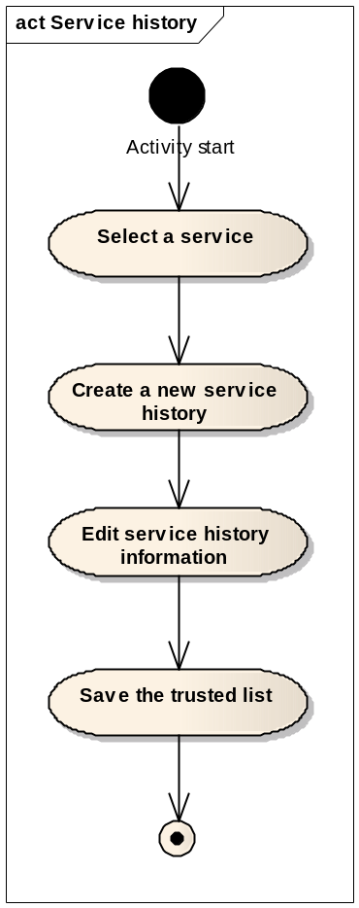
Figure 2: Business process - Add service history
- The user can add a history entry to a specific service; for this, he selects a service among the list of services from a TSP.
- The creation of a service history occurs when the user must introduce a modification in a service requiring a change of its current status.
- The service history entry contains a copy of the service information (including possible extensions) and may be partially modified by the user.
- Finally, the user must confirm the modifications by saving the trusted list.

The following table lists the corresponding use cases for each activity shown in the diagram above.
Add service history
Step | Actor | Realized by
Select a service | TSL User | UC-TSL 1.1 – Edit TSL entry
Create a new service history | TSL User | UC-TSL 1.5 – Add a service history
Edit service history information | TSL User | UC-TSL 1.1 – Edit TSL entry
Save the trusted list | TSL User | UC-TSL 2.2 – Save a TSL

Add service information extension
The following diagram presents the flow of activities that might occur while a user adds a service information extension.
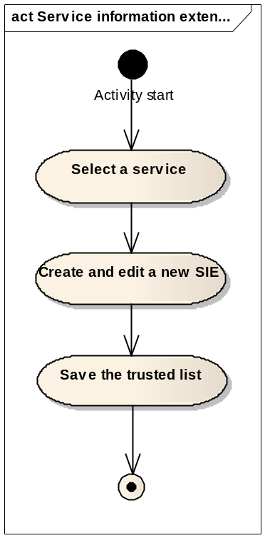
Figure 3: Business process - Add service information extension
- The user can add one or several service information extensions to a selected service. In particular, such an extension is used when the information provided in the “Service digital identity” is not sufficient for unambiguously identifying the qualified certificates.
- The service information extension is also part of the service history when present. Therefore, this extension may differ from a history instance to another.
- Four types of extensions are provided in the service information extension:
  - Qualifications extension;
  - Additional service information extension;
  - Taken over by extension;
  - Revocation information extension.

The following table lists the corresponding use cases for each activity shown in the diagram above.
Add service information extension
Step | Actor | Realized by
Select a service | TSL User | UC-TSL 1.1 – Edit TSL entry
Create and edit a new SIE | TSL User | UC-TSL 1.6 – Add service information extension
Save the trusted list | TSL User | UC-TSL 2.2 – Save a TSL

Change the TSP of a service
The following diagram presents the flow of activities that might occur while a user wants to change the TSP which is responsible for a service.
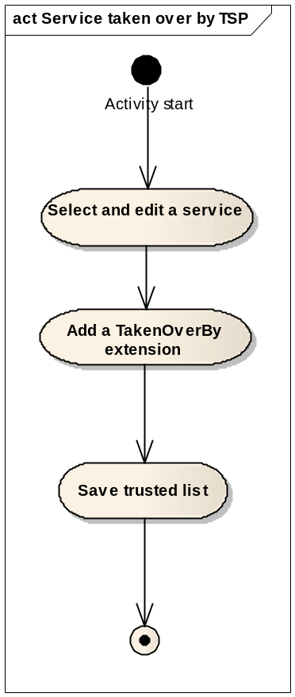
Figure 4: Business process - Change the TSP of a service
- The user can change the TSP which is responsible for a service.
- This modification must be performed in three steps:
  - The user must select the service for which he wants to modify the responsible TSP and change the corresponding information;
  - The user must choose “Add Information Extention” in the Trust Service’s pop-up menu;
  - The user must complete the “Taken Over By” service information extension form;.

The following table lists the corresponding use cases for each activity shown in the diagram above.
Change the TSP of a service
Step | Actor | Realized by
Select and edit a service | TSL User | UC-TSL 1.1 – Edit TSL entry
Add a TakenOverBy extension | TSL User | UC-TSL 1.6 – Add service information extension
Save the trusted list | TSL User | UC-TSL 2.2 – Save a TSL

DSS Applet business processes

Sign a document
The following diagram presents the flow of activities that occur while a user wants to sign a document.
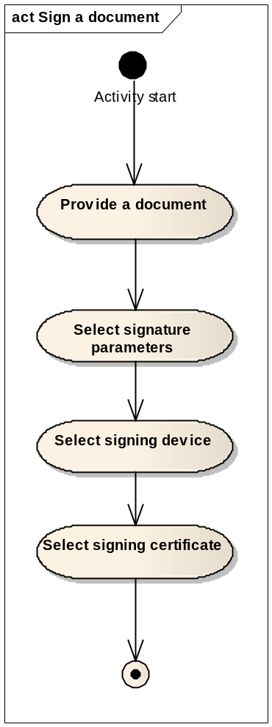
Figure 5: Business process - Sign a document
- The user provides a document to be signed.
- The signature must be set with parameters selected by the user. These are the signature format, the signature level and the wrapping method.
- Several signing devices are supported by the system, the user must specify which one he intends to use.
- A user can possibly have several signing certificates; therefore, he must select the correct signing certificate.

The following table lists the corresponding use cases for each activity shown in the diagram above.
Sign a document
Step | Actor | Realized by
Provide a document | DSS User | UC-DSS 1.1 – Sign a document
Select signature parameters | DSS User | UC-DSS 1.1 – Sign a document
Select signing device | DSS User | UC-DSS 1.1 – Sign a document
Select signing certificate | DSS User | UC-DSS 1.1 – Sign a document

Verify a signature
The following diagram presents the flow of activities that might occur while a user wants to verify the signature of a document.
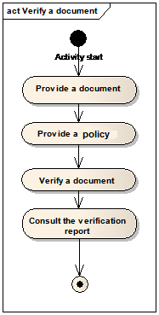
Figure 6: Business process - Verify a document
- A user receiving a signed document can verify its signature;
- The verification is intended to be performed on a signed document, the verification of certificates as an isolated document (without being part of the signature verification of signed document) is out of the scope of this document;
- The validation is driven by the signature validation policy applied. The user can choose between the default policy and its context-specific policy.
- The verification produces a verification simple report containing the aggregated result of all the verification checks. These checks do not depend on the type of signature, but on the time of verification and its result. For example when the signing certificate has expired the long term validation is launched.
- The verification also produces a report detailing the results of the execution of all processes and sub-processes and another report with all input data extracted from the signature and from other external sources (OCSP, CRL, AIA…) used to carry out the validation processes.
The following table lists the corresponding use cases for each activity shown in the diagram above.
Sign a document
Step | Actor | Realized by
Provide a document | DSS User | UC-DSS 1.2 – Verify a signed document
Verify a document | DSS User | UC-DSS 1.2 – Verify a signed document
Consult the verification report | DSS User | UC-DSS 1.2 – Verify a signed document

Use Case Model
In this section, the user requirements and system features are transformed into system specifications formulated in terms of Actors and Use Cases [R10].

Notation Overview
An actor is defined by [R10] as:
- A coherent set of roles that users of the system can have when interacting with it.
- An actor instance can be either an individual or an external system.
An actor is depicted using the stick figure icon shown in the figure below:

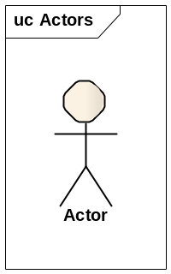
Figure 7: Notation for an actor

Use Case
A Use Case is a sequence of actions a system performs that yields an observable result of value to a particular actor [R10]. A Use Case is represented by an ellipse as depicted in the example below.

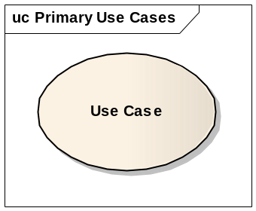
Figure 8: Notation for a Use Case

The interaction between an actor and the system – represented by a Use Case – is denoted by an association link, as in the following figure. The association link may have an arrowhead indicating which element – the actor or the system – initiates the interaction.

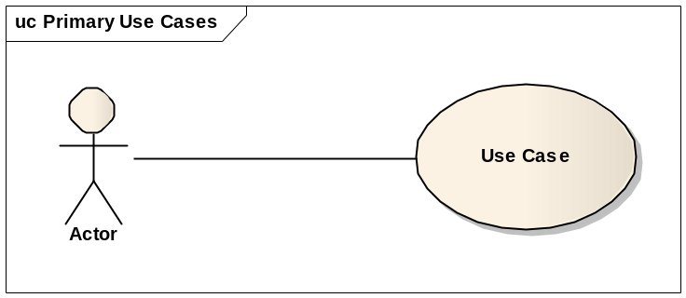
Figure 9: Notation to associate an actor with a Use Case

Use Case Description
In this document, each Use Case sequence of actions of a Use Case is defined via the Use Case Description. The Use Case Description is a textual description which defines the following elements:
- Brief description of the Use Case;
- Actor(s), intervening in the Use Case;
- Pre-condition(s);
- Post-condition(s);
- Main flow, describing the sequence of actions that normally are part of the Use Case realization;
- Alternative flow, describing sequence of actions that may be part of the Use Case realization;
- Exceptional flow, describing sequence of actions that occurs exceptionally during the Use Case realization.

Use Case Inclusion
An include dependency is a generalization relationship denoting the inclusion of the behaviour described by another Use Case. The best way to think of an include dependency is that it is the invocation of a Use Case by another one.
In the Use Case Model diagrams, the Inclusion relationship is visually defined as in the following picture. For example, viewing an object includes searching for it.

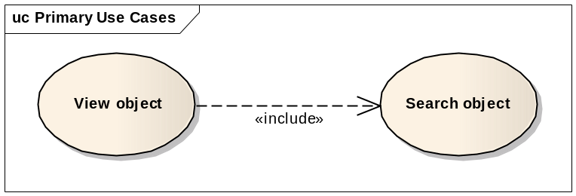
Figure 10: Use Case Inclusion

In the Use Case Description, an Inclusion relationship is defined by the following syntax:
<Include “Search object” Use Case>

Use Case Extension
A Use Case extension is a generalization relationship where an extending Use Case continues the behaviour of a base Use Case. The extending Use Case accomplishes this by conceptually inserting additional action sequences into the base Use Case sequence. This allows an extending Use Case to continue the activity sequence of a base Use Case when the appropriate extension point is reached in the base Use Case and the extension condition is fulfilled. When the extending Use Case activity sequence is completed, the base Use Case continues.
An extending Use Case is, effectively, an alternate course of the base Use Case.
In the Use Case Model diagrams, the Extension relationship is visually defined as in the following picture. For example, the possibility to modify an object when it’s currently viewed can be an extension of the simple display.

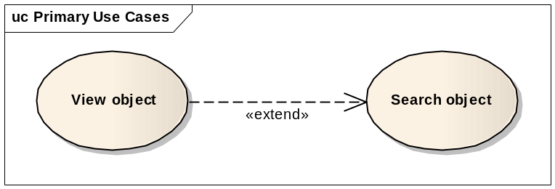
Figure 11: Use Case Extension

Actors
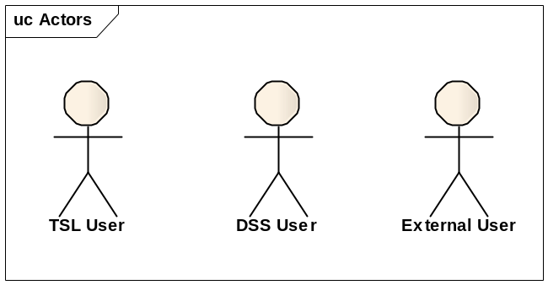
Figure 12: Actors

TSL User
This actor has access to the trusted list management system.

The TSL User is involved in the following use cases:
- UC-TSL 1.1 – Edit TSL entry
- UC-TSL 1.2 – Add pointer to other TSL
- UC-TSL 1.3 – Add a TSP
- UC-TSL 1.4 – Add a service
- UC-TSL 1.5 – Add a service history
- UC-TSL 1.6 – Add service information extension
- UC-TSL 1.7 – Delete a TSL entry
- UC-TSL 1.8 – Manage multilingual field
- UC-TSL 1.9 – Manage multivalued field
- UC-TSL 2.1 – Create a new TSL
- UC-TSL 2.2 – Save a TSL
- UC-TSL 2.3 – Open a TSL
- UC-TSL 2.4 – Sign a TSL

DSS User
This actor has access to the DSS Web system.

The DSS User is involved in the following use cases:
- UC-DSS 1.1 – Sign a document
- UC-DSS 1.2 – Verify a signed document
- UC-DSS 1.3 – Extend a document signature

External User
This actor represents an external system (a software) which has access to DSS functionalities.
The External User is involved in the following use cases:
- UC-DSS 1.4 – WS get document digest
- UC-DSS 1.5 – WS sign a document
- UC-DSS 1.6 – WS verify a signed document
- UC-DSS 1.7 – WS extend a document signature

Use Case Model

TSL Editing use cases
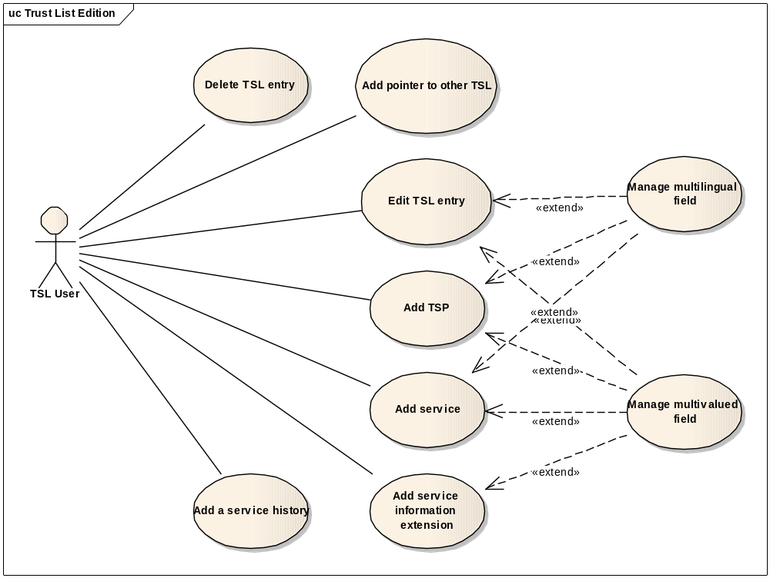
Figure 13: TSL editing use case diagram

UC-TSL 1.1 – Edit TSL entry
Brief Description | The trusted list structure as described in [R02] has been organised in different pages in the system:  - TSL information page  - Pointer to other TSL page  - TSP information page  - Service current status information page  - Service status history page  - Service information extension page  - Qualification extension page  All these pages content a part of the trusted list and are described in the section Trusted List user interfaces.  The system proposes a Navigation tree allowing an actor to access and edit each existing page.  This use case describes the generic behaviour of the system when an actor edits the existing information.
Primary Actor | TSL User
Secondary Actors | None
Trigger | User’s request
Preconditions | None
Postconditions | The user has modified the TSL entry.
Basic Flow of Events | Step | Action
Basic Flow of Events | 1 | The actor clicks on the intended entry in the navigation tree.
Basic Flow of Events | 2 | The system displays the corresponding page.
Basic Flow of Events | 3 | The actor modified one or more fields and saves.
Basic Flow of Events | 4 | The system stores the edited information.
Alternative Flow | Step | Branching Action
Alternative Flow | Manage multilingual value  The user has the possibility to provide a translation for specific fields.
Alternative Flow | 3a | UC-TSL 1.8 – Manage multilingual field
Alternative Flow | 4a | The main flow continues at point 2.
Error Flow | Step | Exception
Error Flow | None
Additional Requirements | None
Additional Information | New trusted list  At creation time, a new trusted list is empty and the navigation tree contains only the root (see UC-TSL 2.1 – Create a new TSL).

UC-TSL 1.2 – Add pointer to other TSL
Brief Description | This use case describes how to add a pointer to other TSL to the trusted list.
Primary Actor | TSL User
Secondary Actors | None
Trigger | User’s request
Preconditions | None
Postconditions | The actor added a pointer to other TSL.
Basic Flow of Events | Step | Action
Basic Flow of Events | 1 | The actor triggers the action “Add pointer to other TSL”.
Basic Flow of Events | 2 | The system creates a new empty pointer to other TSL entry in the trusted list.
Basic Flow of Events | 3 | The system displays the Pointer to other TSL page.
Basic Flow of Events | 4 | The actor specifies the requested information and saves.
 | 5 | The system saves the edited information.
Alternative Flow | Step | Branching Action
Alternative Flow | None
Error Flow | Step | Exception
Error Flow | None
Additional Requirements | None
Additional Information | In case of LOTL, the number of pointers to other TSL is not limited. In case of Member State trusted list, the number of pointers to other TSL is strictly fixed to 2 (i.e. Pointers to LOTL)  For convenience, a template of the trusted list prefilled with the 2 pointers to LOTL is provided to be reused.  The verification performed in UC-TSL 2.4 – Sign a TSL will check this constraint using the TSL type defined in the configuration file (See section List generation).

UC-TSL 1.3 – Add a TSP
Brief Description | This use case describes how to add a trusted service provider to the trusted list.  A TSP is not a mandatory entry, but if present, a TSP must have at least one service under its responsibility.
Primary Actor | TSL User
Secondary Actors | None
Trigger | User’s request
Preconditions | None
Postconditions | A new TSP has been created in the trusted list.
Basic Flow of Events | Step | Action
Basic Flow of Events | 1 | The actor triggers the action “Add a TSP”.
 | 2 | The system creates a new empty TSP entry in the trusted list and a new empty service for the TSP.
 | 3 | The system displays the TSP information page.
 | 4 | The actor provides the requested information and saves.
 | 5 | The system stores the edited information.
Alternative Flow | Step | Branching Action
Alternative Flow | Manage multilingual value  The user has the possibility to provide a translation for specific fields.
 | 4a | UC-TSL 1.8 – Manage multilingual field
 | 5a | The main flow continues at point 3.
Error Flow | Step
Error Flow | None
Additional Requirements | None
Additional Information | The number of TSP added to the trusted list is not limited.

UC-TSL 1.4 – Add a service
Brief Description | This use case describes how to add a new service to a TSP.  The number of services is not limited for a TSP. All information provided during this use case can be lately modified (see UC-TSL 1.1 – Edit TSL entry).
Primary Actor | TSL User
Secondary Actors | None
Trigger | User’s request.
Preconditions | At least one TSP has been created previously.
Postconditions | The actor has added a service to the corresponding TSP.
Basic Flow of Events | Step | Action
Basic Flow of Events | 1 | The actor selects a TSP in the navigation tree and triggers the action “Add a service”.
Basic Flow of Events | 2 | The system creates a new empty service entry in the TSP list of services.
Basic Flow of Events | 3 | The system displays the Service current status information page.
Basic Flow of Events | 4 | The actor provides the requested information and saves.
Basic Flow of Events | 5 | The system stores the edited information.
Alternative Flow | Step | Branching Action
Alternative Flow | Manage multilingual value  The user has the possibility to provide a translation for specific fields.
Alternative Flow | 4a | UC-TSL 1.8 – Manage multilingual field
Alternative Flow | 5a | The main flow continues at point 3.
Alternative Flow | Manage multivalued field  The actor has the possibility to provide several values for specific fields.
Alternative Flow | 4a | UC-TSL 1.9 – Manage multivalued field
Alternative Flow | 5a | The main flow continues at point 3.
Error Flow | Step | Exception
Error Flow | None
Additional Requirements | None
Additional Information | The number of services added to a TSP is not limited.
.

UC-TSL 1.5 – Add a service history
Brief Description | This use case describes how to add a history entry to a service.  The creation of a service history occurs when the user must introduce a modification in a service requiring a change of its current status. Therefore, The actor must provide a new current status and a new status starting date.  This functionality has two effects:  - Create a history entry for the service with a copy of the old service information.  - Change the current status of the service and its starting date.  This use case ends by displaying the Service status history page and allows the actor to potentially modify service history information.  Additional modifications on the current status service information can be performed with UC-TSL 1.1 – Edit TSL entry.
Primary Actor | TSL User
Secondary Actors | None
Trigger | User’s request.
Preconditions | At least one service has been created previously.
Postconditions | A history entry has been added to the corresponding service and the current status information has been changed.
Basic Flow of Events | Step | Action
Basic Flow of Events | 1 | The actor selects a service in the navigation tree and triggers the action “Add a service history”.
Basic Flow of Events | 2 | The system displays the New status page.
Basic Flow of Events | 3 | The actor provides the following information and saves:  - A new current status;  - A new status starting date.
Basic Flow of Events | 4 | The system performs the following actions:  - Creates a new service history entry for this service and possibly all the service information extension entries related to the service.  - Fills the history entry using the old service information.  - Changes the current status and status starting date in the Service current status information page with new information.  - The system stores the edited information.  - Displays the Service status history page.
Alternative Flow | Step | Branching Action
Alternative Flow | None
Error Flow | Step | Exception
Error Flow | None
Additional Requirements | Starting date  The new status starting cannot be earlier than the current status starting date.  Service digital identity  X.509 certificates are not copied in historical entries.  New status  The new status versus previous status must be in line with status flow imposed in [R02].
Additional Information | None

UC-TSL 1.6 – Add service information extension
Brief Description | A “service information extension” is used to provide enhanced service-related information.  In particular, this information is provided when the “Service digital identifier” is not sufficient to unambiguously identify the qualified certificates issued by this service.  This use case describes how an actor can add a “service information extension” to a selected service.  As described in section 4.3.1.5.5 Service information extension page, the service information extension can be of four kinds:  - Qualifications extension  - Additional service information extension  - TakenOverBy extension  - ExpiredCertsRevocationInfo extension
Primary Actor | TSL User
Secondary Actors | None
Trigger | User’s request.
Preconditions | At least one service has been created previously.
Postconditions | An extension entry has been added to the corresponding service.
Basic Flow of Events | Step | Action
Basic Flow of Events | 1 | The actor selects a service or a service history in the navigation tree and triggers the action “Add service information extension”.
Basic Flow of Events | 2 | The system creates a new empty service information extension entry in the list of corresponding service extensions.
Basic Flow of Events | 3 | The system displays the Service information extension page.
Basic Flow of Events | 4 | The actor provides the requested information and saves.
Basic Flow of Events | 5 | The system stores the edited information.
Alternative Flow | Step | Branching Action
Alternative Flow | Manage multivalued field  The actor has the possibility to provide several values for the following field:  - Policy identifier
Alternative Flow | 4a | UC-TSL 1.9 – Manage multivalued field
Alternative Flow | 5a | The main flow continues at point 3.
Alternative Flow | Step | Branching Action
Alternative Flow | Add qualification extension  Qualification extension is a particular extension which is not directly part of the Service information extension page. The actor has the possibility to provide this extension via a specific page
Alternative Flow | 4b | The actor selects the service information extension in the navigation tree and triggers the action “Add qualification extension”.
Alternative Flow | 5b | The system creates a new empty qualification extension entry in the list of corresponding qualification extensions.
Alternative Flow | 6b | The system displays the Qualification extension page.
Alternative Flow | 7b | The actor provides the requested information and saves.
Alternative Flow | 8b | The system stores the edited information.
Alternative Flow | 9b | The main flow continues at point 3.
Error Flow | Step | Exception
Error Flow | None
Additional Requirements | None
Additional Information | The number of service information extension added to a service is not limited.  Relations  An actor can add a service information extension to a service and also to a service history independently.

UC-TSL 1.7 – Delete a TSL entry
Brief Description | All components of the trusted list can be deleted by an actor except the trusted list itself.  An actor can select an entry in the navigation tree and delete it with all associated components.
Primary Actor | TSL User
Secondary Actors | None
Trigger | User’s request.
Preconditions | None
Postconditions | The selected entry has been deleted.
Basic Flow of Events | Step | Action
Basic Flow of Events | 1 | The actor selects an entry in the navigation tree and deletes it.
Basic Flow of Events | 2 | The system displays a warning: “Confirm deletion.”
Basic Flow of Events | 3 | The actor confirms the deletion.
Basic Flow of Events | 4 | The system deletes the entry and all its components.  The system displays the TSL information page.
Alternative Flow | Step | Branching Action
Alternative Flow | Cancel
Alternative Flow | 3a | The actor cancels the deletion.
Alternative Flow | 4a | The system displays the page of the current entry.
Error Flow | Step | Exception
Error Flow | None
Additional Requirements | None
Additional Information

UC-TSL 1.8 – Manage multilingual field
Brief Description | Some specific fields can be described in several languages.  This use case specifies how an actor provides values for different languages for a field.
Primary Actor | TSL User
Secondary Actors | None
Trigger | User’s request.
Preconditions | None
Postconditions | The user has added or deleted a translation of the field in the desired language.
Basic Flow of Events | Step | Action
Basic Flow of Events | 1 | The actor clicks on the button “Add” of the corresponding field.
Basic Flow of Events | 2 | The system adds a new empty multilingual field.
Basic Flow of Events | 3 | The actor:  - Selects the language;  - Provides the new value.
Alternative Flow | Step | Branching Action
Alternative Flow | Delete a multilingual value
Alternative Flow | 1a | The actor clicks on the button “Delete” of the corresponding multilingual field.
 | 2a | The system deletes the multilingual field
Error Flow | Step | Exception
Error Flow | None
Additional Requirements | None
Additional Information | The list of the fields for which the actor can specify multilingual values is describes in the section Multilingual field type.

UC-TSL 1.9 – Manage multivalued field
Brief Description | Some fields can be provided with multiple values. Example: policy identifier.  This use case specifies how an actor provides values for a multivalued field.
Primary Actor | TSL User
Secondary Actors | None
Trigger | User’s request.
Preconditions | None
Postconditions | The actor has added or deleted a value for a multivalued field
Basic Flow of Events | Step | Action
Basic Flow of Events | 1 | The actor clicks on the button “Add” of the corresponding multivalued field.
Basic Flow of Events | 2 | The system adds a new empty field.
Basic Flow of Events | 3 | The actor provides the new value to the multivalued field.
Alternative Flow | Step | Branching Action
Alternative Flow | Delete a value
Alternative Flow | 1a | The actor clicks on the button “Remove” of the corresponding field.
Alternative Flow | 2a | The system deletes the field.
Error Flow | Step | Exception
Error Flow | None
Additional Requirements | None
Additional Information | The list of the fields for which the actor can specify multiple values is describes in the section Multivalued field type.

TSL Management use cases
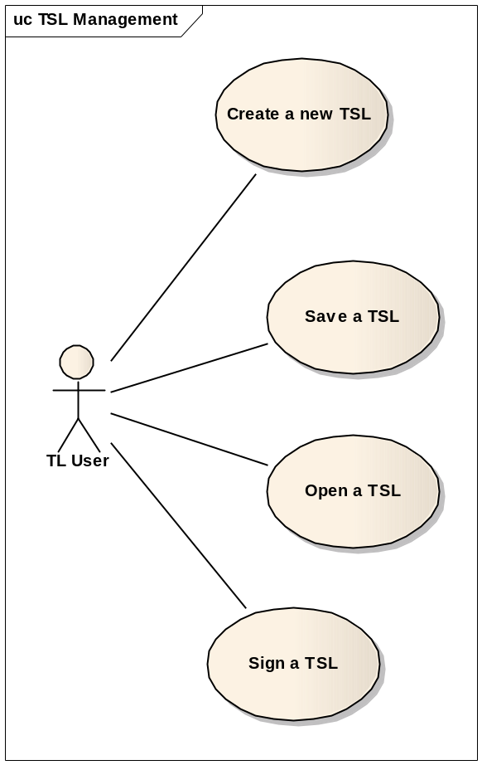
Figure 14: TSL Management use case diagram

UC-TSL 2.1 – Create a new TSL
Brief Description | This use case describes how to create a new instance of a trusted list or LOTL.  The new list is empty and should be completed.
Primary Actor | TSL User
Secondary Actors | None
Trigger | User’s request.
Preconditions | None
Postconditions | A new empty trusted list has been created.
Basic Flow of Events | Step | Action
Basic Flow of Events | 1 | The actor clicks on the menu “New”
Basic Flow of Events | 2 | The system creates a new TSL entry as root of the navigation tree.  The system displays the TSL information page.
Alternative Flow | Step | Branching Action
Alternative Flow | None
Error Flow | Step | Exception
Error Flow | None
Additional Requirements | None
Additional Information | None

UC-TSL 2.2 – Save a TSL
Brief Description | This use case describes how to save the current version of the list.
Primary Actor | TSL User
Secondary Actors | None
Trigger | User’s request.
Preconditions | None
Postconditions | The system has stored the trusted list.
Basic Flow of Events | Step | Action
Basic Flow of Events | 1 | The actor clicks on the menu “Save”
Basic Flow of Events | 2 | The system saves the TSL.
Alternative Flow | Step | Branching Action
Alternative Flow | Step | Exception
Alternative Flow | Save as
Alternative Flow | 1a | The actor clicks on the menu “Save as”.
Alternative Flow | 2a | The system displays a “file chooser”.
Alternative Flow | 3a | The actor specifies:  - The location of the new file;  - The name of the new file.  The actor click on the button “Save”.
Alternative Flow | 4a | The system stores the TSL with the information provided.
Alternative Flow | Save a new trusted list
Alternative Flow | 1b | If the trusted list is new and has never been saved, the action “Save” will act like the action “Save as”.  The alternative flow continues at step 2a.
Error Flow | Step | Exception
Error Flow | None
Additional Requirements | None
Additional Information | None

UC-TSL 2.3 – Open a TSL
Brief Description | This use case describes how an existing instance of a trusted list is opened.  It is used when an actor wants to reuse a previous version of a trusted list or a template.
Primary Actor | TSL User
Secondary Actors | None
Trigger | User’s request.
Preconditions | None
Postconditions | The specified trusted list is loaded in the system.
Basic Flow of Events | Step | Action
Basic Flow of Events | 1 | The actor clicks on the menu “Open”.
Basic Flow of Events | 2 | The system displays a “file chooser”.
 | 3 | The actor specifies the file and clicks on the button “Open”.
 | 4 | The system performs a syntactical check and displays the TSL information page.
Alternative Flow | Step | Branching Action
Alternative Flow | 4a | The system performs a syntactical check and detects that this is of an old version of the trusted list. The automated conversion is performed to fit the new format [R20]. The user is warned about the conversion and the TSL information page is displayed.
Error Flow | Step | Exception
Error Flow | Invalid file
Error Flow | 4a | The system displays an error: “The selected file is not a valid trusted list and cannot be opened.”  The action is aborted.
Additional Requirements | None
Additional Information | The system parses the file and checks its compliance with the syntactical rules.  The validation of the content of the list is performed during UC-TSL 2.4 – Sign a TSL.  In the case of conversion of a trusted list encoded with the old format, the converted file is not saved automatically.

UC-TSL 2.4 – Sign a TSL
Brief Description | The trusted list needs to be signed before its publication.  This signature can be done using at least the following means:  - PKCS#11 (Smart card reader);  - PKCS#12 (Signature file);  - MS CAPI (Windows signature).  In addition, this use case will perform a validation of the current trusted list in order to check that all mandatory fields and business rules.
Primary Actors | TSL User
Secondary Actors | None
Trigger | User’s request.
Preconditions | None
Postconditions | The trusted list has been signed.
Basic Flow of Events | Step | Action
Basic Flow of Events | 1 | The actor clicks on the menu “Sign”.
Basic Flow of Events | 2 | The system performs the validation of the trusted list and displays the Sign TSL page.
Basic Flow of Events | 3 | The actor clicks on button “Next.
Basic Flow of Events | 4 | The actor selects the certificate source, the required parameters and clicks on button “Next”
Basic Flow of Events | 5 | The actor selects the signing certificate, the output file and clicks on button “Next”
Basic Flow of Events | 6 | The system confirms the signature.
Alternative Flow | Step | Branching Action
Alternative Flow | Cancel
Alternative Flow | 3a | The actor cancels the signature.
Alternative Flow | 4a | The system displays the TSL information page.
Alternative Flow | PKCS#11 and MS CAPI certificate source
Alternative Flow | 6b | The actor provides the smart cart PIN code  The basic flow continues at step 6.
Error Flow | Step | Exception
Error Flow | Validation failed  This exception occurs when the validation raises error(s). The validation results are displayed and the TSL cannot be saved until the errors are corrected.
Error Flow | 3b | The system displays an error message: “As the validation contains errors; it is not possible to continue.  The alternative flow continues at step 3a.
Additional Requirements | Trusted list validation  The verification on the trusted list content is performed at the time of signature. This will check:  - Mandatory fields;  - Business rules.
Additional Information | None

DSS Web use cases
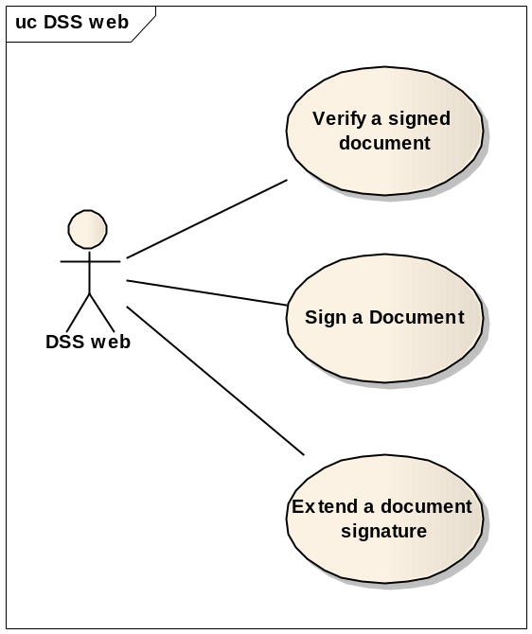
Figure 15: DSS use cases diagram

UC-DSS 1.1 – Sign a document
Brief Description | This use case describes how an actor can electronically sign a document. This signature is performed according to information provided by the actor and a set of parameters coming from a configuration file.  The used parameters depend on the information provided.  The result of this use case is a signed version of the original document.
Primary Actors | DSS User
Secondary Actors | None
Trigger | User’s request.
Preconditions | None
Postconditions | The document has been signed.
Basic Flow of Events | Step | Action
Basic Flow of Events | 1 | The actor provides a document to be signed.
Basic Flow of Events | 2 | The actor selects the format, the packaging and the level of the signature he wants to apply to the provided document.
Basic Flow of Events | 3 | The actor selects the PKCS#11 signature token API.
Basic Flow of Events | 4 | The actor provides the PKCS#11 library.
Basic Flow of Events | 5 | The actor selects the signing certificate and potentially the signature policy identifier and claimed role.
Basic Flow of Events | 6 | The actor chooses the destination file and confirms (with PIN code in case of PKCS#11 and MS CAPI)
Basic Flow of Events | 7 | The system confirms the signature of the document.
Alternative Flow | Step | Branching Action
Alternative Flow | PKCS#12 API
Alternative Flow | 3b | The actor selects the PKCS#12 token API.
Alternative Flow | 4b | The actor provides the PKCS#12 file and related password.  The basic flow continues at step 5.
Alternative Flow | MS CAPI
Alternative Flow | 3c | The actor selects the MS CAPI token.  The basic flow continues at step 5.
Error Flow | Step | Exception
Error Flow | Signature failure
Error Flow | 7d | If the system cannot retrieve the required parameters to perform the requested signature, it displays a warning:  “Impossible to perform the signature of the document, please verify signature parameters or contact the administrator of the system”.
Additional Requirements | Signature format  The available signature formats are:  - XML signature (XAdES)  - Binary signature (CAdES)  - PDF signature (PAdES)  - ASiC signature (ASiC-S)  The PDF signature format can be selected only if the document format is of type PDF.  Signature level  The available signature levels depend on the format of the signature.  XML and binary signature [R04], [R07]:  - Basic electronic signature;  - Policy based basic electronic signature;  - Electronic signature with timestamp;  - Electronic signature with complete validation references;  - Extended signature with timestamp on the references;  - Extended long-term electronic signature with actual certificates and revocation lists;  - Archival electronic signature with periodical timestamps.  PDF signature [R17]:  - Basic electronic signature;  - Policy based basic electronic signature;  - Long term validation signature.  ASiC signature [R09]:  - Basic electronic signature;  - Policy based basic electronic signature;  - Electronic signature with time;  - Electronic signature with complete validation references;  - Extended signatures with time forms;  - Extended long electronic signatures with time;  Wrapping method  The available wrapping methods are described in the section Packaging method.  Signature means  - PKCS#11 (Smart card reader);  - PKCS#12 (Signature file);  - MS CAPI (Windows signature).
Additional Information | Configuration  The digest algorithm and signature algorithm is part of the configuration parameters set in the server side. This is performed for each instance of the system using Configuration file.  Multiple signature  Signing a document with several signatures is possible but successively. The actor must sign the document with each signature, one by one.

UC-DSS 1.2 – Verify a signed document
Brief Description | This use case allows a user to check if a signed document is valid or not.  The use case provides a simple verification report with the indication and sub-indication if any. All the information used by the validation processes are also made available to the user.
Primary Actors | DSS User
Secondary Actors | None
Trigger | User’s request.
Preconditions | None
Postconditions | A verification report has been produced.
Basic Flow of Events | Step | Action
Basic Flow of Events | 1 | The actor provides a signed document and triggers the verification.
Basic Flow of Events | 2 | The system produces a simple verification report based on:  - The content type of the document;  - The default validation policy;  - The format of the signature;  - The time of the validation;  - The packaging and wrapping method of the signature;  - The content obtained from different sources such as OCSP, CRL, AIA, …;  - The Member States trusted lists.
Alternative Flow | Step | Branching Action
Alternative Flow | Detached signature
Alternative Flow | 1a | The actor provides a detached signature and the original document.  The basic flow continues at step 2
Alternative Flow | Choice of a validation policy
Alternative Flow | 1b | The actor provides a specific validation policy constraints file and triggers the validation.
Alternative Flow | 2b | The system produces a simple verification report based on:  - The specific validation policy;
Error Flow | Step | Exception
Error Flow | None
Additional Requirements | None
Additional Information | None

UC-DSS 1.3 – Extend a document signature
Brief Description | The signature of a document can be extended by an actor e.g. for long term conservation.  This use case describes how an actor can extend a signature.  This extension will not affect the original signature which does not compromise the document.  As the extension only manipulates unsigned data of the signature, this modification does not require to be signed by the original signer.
Primary Actors | DSS User
Secondary Actors | None
Trigger | User’s request.
Preconditions | None
Postconditions | The signature of the document has been extended to the required level.
Basic Flow of Events | Step | Action
Basic Flow of Events | 1 | The actor provides a signed document, selects the level until which he wants to extend the signature and choose the destination file.  The actor triggers the extension of the signature.
Basic Flow of Events | 2 | The system extends the signature according to the specified level.
Alternative Flow | Step | Branching Action
Alternative Flow | Level Already reached
Alternative Flow | 2a | If the requested level of the extension is not stronger than the original signature level, the systems displays a warning: “The existing signature level is at least equal to the requested level. A ‘downgrade’ is not possible.”
Alternative Flow | Detached level A extension  When extending a detached signature up to level –A, the original file must be provided.
Alternative Flow | 1b | The actor provides the detached signature and the original document, selects the level –A and the destination file.  The basic flow continues at step 2.
Error Flow | Step | Exception
Error Flow | None
Additional Requirements | Extension level  The available levels of signature extension depend on the signature format as described in the following table.
  Level / Format | XML | Binary | ASiC | PDF
  Electronic signature with time | X | X | X
  Electronic signature with complete validation references | X | X | X
  Extended signature with time forms | X | X | X
  Extended long electronic signature with time | X | X | X
  Archival electronic signature | X | X | X
  Long Term Validation |  |  |  | X
Additional Information | Configuration  The digest algorithm and signature algorithm is part of the configuration parameters set in the server side.

DSS Webservice use cases
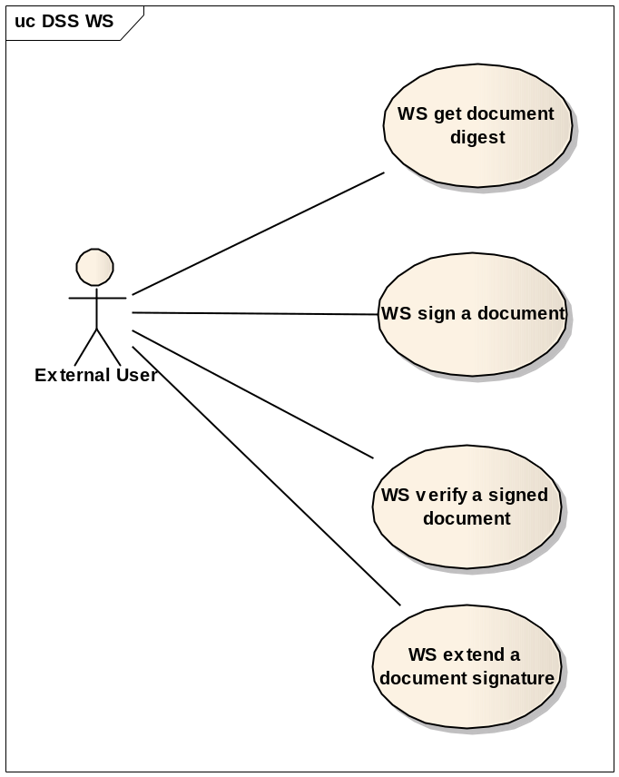
Figure 16: DSS WS use cases diagram

UC-DSS 1.4 – WS get document digest
Brief Description | The system provides a webservice that allows an external user (a software system) to get the digest value computed on a provided document.  This digest value may be used at a later time in combination with UC-DSS 1.5 – WS sign a document to build a complete valid signature.
Primary Actors | External User
Secondary Actors | None
Trigger | User’s request.
Preconditions | None
Postconditions | A digest value is returned to the actor.
Basic Flow of Events | Step | Action
Basic Flow of Events | 1 | The actor calls the web service and provides the document and the signing parameters.
Basic Flow of Events | 2 | The system computes the digest and returns it to the actor.
Alternative Flow | Step | Branching Action
Alternative Flow | None
Error Flow | Step | Exception
Error Flow | Wrong argument
Error Flow | 2a | If the system cannot compute the digest using the provided parameters, an error is returned to the actor.
Additional Requirements | Signing parameters  The following parameters must be provided:  - Signing time  - Signing certificate  - Certification chain  - Signature format  - Signature wrapping  - Digest algorithm  - Signing algorithm  - Claimed role (optional)  - Policy identifier (optional)  - Production place (optional)  - AllDataObjects timestamp (optional)  - IndividualDataObjects timestamp (optional)
Additional Information | Configuration  The digest algorithm is part of the configuration parameters set on the server side.

UC-DSS 1.5 – WS sign a document
Brief Description | The system provides a webservice that allows an external user to get a signed document built when it provides an unsigned document, a signed digest value that fits to the document and signature parameters.  The signature parameters specify which kind of signature shall be applied to the document.
Primary Actors | External User
Secondary Actors | None
Trigger | User’s request.
Preconditions | None
Postconditions | A signed document is returned to the actor.
Basic Flow of Events | Step | Action
Basic Flow of Events | 1 | The actor calls the web service and provides:  - The document to be signed;  - The signed digest value (previously computed on the document);  - The signature parameters.
Basic Flow of Events | 2 | The system computes the digest and verifies the compliance with the provided signed digest (using the certificates which are part of the signature parameters).
Basic Flow of Events | 3 | The system produces the signed document based on the provided parameters and returns it to the actor.
Alternative Flow | Step | Branching Action
Alternative Flow | None
Error Flow | Step | Exception
Error Flow | Digest Error
Error Flow | 2a | If the computed digest doesn’t match the provided signed digest, an error is returned to the actor.
 | Signature failure
 | 3b | If the system cannot apply a signature to the document using the provided signature information, an error is returned to the actor.
Additional Requirements | Signing parameters  The following parameters must be provided:  - Signature level  - Signing time  - Signing certificate  - Certification chain  - Signature format  - Signature wrapping  - Digest value  - Digest algorithm  - Signing algorithm  - Claimed role (optional)  - Policy identifier (optional)  - Production place (optional)  - AllDataObjects timestamp (optional)  - IndividualDataObjects timestamp (optional)
Additional Information | Configuration  The digest algorithm and signature algorithm is part of the configuration parameters set on the server side.  Multiple signature  Signing a document with several signatures is possible but successively. The actor must sign the document with each signature, one by one.

UC-DSS 1.6 – WS verify a signed document
Brief Description | The system provides a webservice that allows an external system to perform a verification of a document.
Primary Actors | External User
Secondary Actors | None
Trigger | User’s request.
Preconditions | None
Postconditions | A verification report has been produced and returned to the actor.
Basic Flow of Events | Step | Action
Basic Flow of Events | 1 | The actor calls the web service and provides a signed document.
Basic Flow of Events | 2 | The system produces a verification report based on:  - The content type of the document;  - The format of the signature;  - The level of the signature;  - The packaging method of the signature;  - The Member States trusted lists.  The system returns the report to the actor.
Alternative Flow | Step | Branching Action
Alternative Flow | None
Error Flow | Step | Exception
Error Flow | None
Additional Requirements | None
Additional Information | None

UC-DSS 1.7 – WS extend a document signature
Brief Description | A provided webservice allows the signature’s extension of a document with the same result as the DSS web functionality.
Primary Actors | External User
Secondary Actors | None
Trigger | User’s request.
Preconditions | None
Postconditions | The document with an extended signature up to the provided level is returned to the actor.
Basic Flow of Events | Step | Action
Basic Flow of Events | 1 | The actor calls the web service and provides:  - The signed document;  - The requested level of signature.
Basic Flow of Events | 2 | The system extends the signature according to the specified level and returns it to the actor.
Alternative Flow | Step | Branching Action
Alternative Flow | Level Already reached
Alternative Flow | 2a | If the requested level of the extension is not stronger than the original signature level, the systems displays a warning: “The existing signature level is at least equal to the requested level. A ‘downgrade’ is not possible.”
Error Flow | Step | Exception
Error Flow | Format compliance
Error Flow | 2b | If the requested level of signature is not applicable to the signature format as specified in the additional requirements, the system returns an error to the actor.
Additional Requirements | Extension level  The available levels of signature extension depend on the signature format as described in the following table.
  Level / Format | XML | Binary | ASiC | PDF
  Electronic signature with time | X | X | X
  Electronic signature with complete validation references | X | X | X
  Extended signature with time forms | X | X | X
  Extended long electronic signature with time | X | X | X
  Archival electronic signature | X | X | X
  Long Term Validation |  |  |  | X
Additional Information | None

Analysis Model

Notation overview

Entity diagram
Entity
An entity represents a significant and persistent piece of information that is manipulated by Actors of the system. An entity can be used in many different use cases and usually outlives any single interaction.
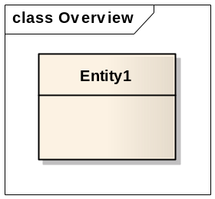
Figure 17: Notation for an Entity
Associations
The Aggregation is represented by an association line with a hollow diamond at the tail end. An aggregation models the notion that one object (Entity 1) uses another object (Entity 2) without “owning” it and thus is not responsible for its creation or destruction.
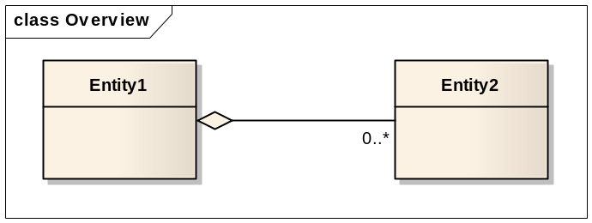
Figure 18: Notation for an Aggregation
The composition is represented by an association line with a solid diamond at the tail end. A composition models the notion of one object (Entity 1) “owning” another (Entity 2) and thus being responsible for the creation and destruction of another object.
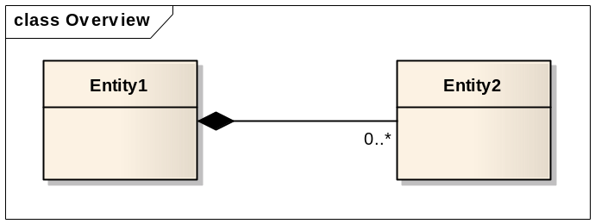
Figure 19: Notation for a Composition

The inheritance is represented by an association with arrowhead that points from a sub-class to a super-class or from a sub-interface to its super-interface. The inheritance models the notion that an entity (Entity 1) is a “kind of” another entity (Entity 2).
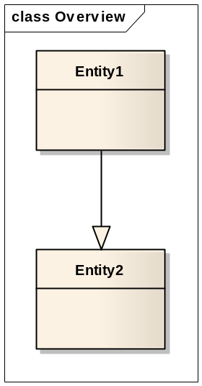
Figure 20: Notation for Inheritance

State diagram
State
A state is represented by a rectangle with rounded corners and compartments. It represents the state of an object at an instant of time. In a state diagram, there will be multiple of such symbols, one for each state of the object we are discussing.

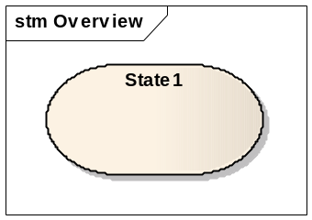
Figure 21: Notation for a State

Transition
A transition is represented by an arrow indicating the object to transition from one state (State1) to another (State 2).
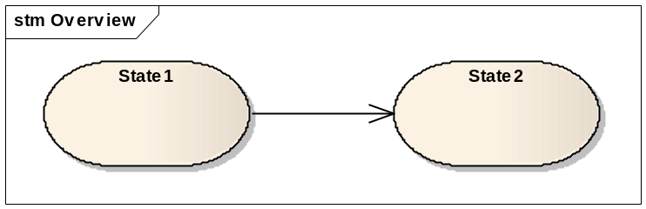
Figure 22: Notation for a Transition

Entities and Business Rules
The business rules described in this section have been specified, in addition of the configuration files and the User interfaces’ constraints, in order to respect the results of the conformance checker available at http://tsl-portal.etsi.org/pub/index.shtml.

Trusted list entities
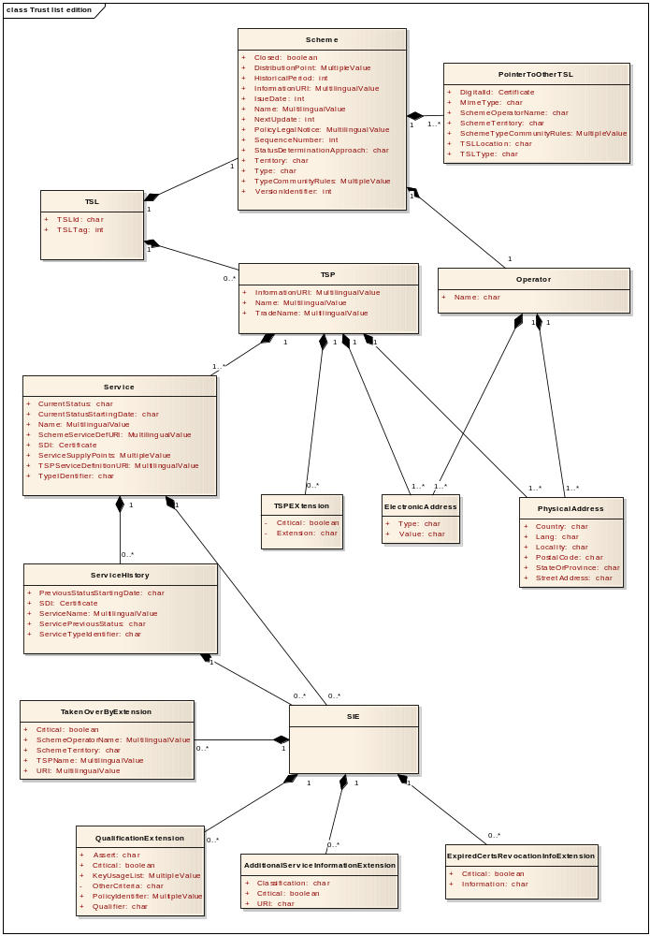
Figure 23: Trusted list entities

Trusted list
Remark: the exact description of the required properties of the trusted list can be found in [R02].

Attributes
Property | Description
TSLTag | A unique value used to facilitate the TSL identification during electronic searches.
TSLId | The identifier of the TSL.

Associations

List of trust service provider
Property | Description
TSP | The list of TSP

Scheme
Property | Description
Scheme | Holds the scheme related to the trusted list.

Rules

Mandatory scheme
The scheme is a mandatory association. A trusted list is related to one and only one scheme.

Scheme

Attributes
Property | Description | Default value
VersionIdentifier | This field specifies the version of the TSL format and will only be incremented when the rules for parsing the TSL change. | 4
SequenceNumber | This field specifies the incremental sequence number of the TSL. At the first release of the TSL the value shall be “1”. A modification of the VersionIdentifier must not recycle the SequenceNumber.
Type | It indicates the type of the TSL which will permit a parser to determine which form of any following fields to expect.
Name | The name of the scheme under which the scheme operates.
InformationURI | Specifies the URI(s) where users can obtain scheme-specific information.
StatusDeterminationApproach | Specifies the scheme’s status determination approach which indicates the general types of criteria being applied.
TypeCommunityRules | Registered URI(s) by which user denotes participation within a community.
Territory | The country or territory in which the scheme is established.
PolicyLegalNotice | Specifies the scheme’s policy or a notice concerning the legal status of the scheme.
HistoricalPeriod | The duration over which historical information in the TSL is provided.
IssueDate | The date and time on which the TSL was issued.
NextUpdate | Specifies the latest date and time by which the next TSL will be issued.
DistributionPoint | Specifies locations where the current TSL is published and where updates can be found.

Associations

Pointer to other TSL
Property | Description
PointerToOtherTSL | The list of Pointer to other TSL.

Scheme operator
Property | Description
SchemeOperator | Specifies the information about the operator which maintains the scheme.

Rules

IssueDate
IssueDate must not be ulterior to the current time.

NextUpdate
If Nextupdate is not empty, the difference between IssuedDate and NextUpdate cannot exceed 6 months.

SequenceNumber format
The SequenceNumber must be an integer and equal or greater than 1.

Scheme Name
The scheme name must be a string structured as follows:
- CC:name_value
Where
- CC = the ISO 3166-1 alpha-2 Country Code;
- Name_value = the text filled by the user and describing the name of the scheme.

HistoricalPeriod
Depending of the TSL type, the field HistoricalPeriod must be:
- Equal to 3653.

Pointer to other TSL
If the type of the TSL is “EUgeneric”, the number of pointer to other TSL must be equal to 2.

TypeCommunityRule
If Type = ”EUgeneric”, there must be at least 2 URIs in TypeCommunityRule.
If Type = ”EUlistofthelists”, there must be only 1 URI in TypeCommunityRule.

Operator

Attributes
Property | Description
Name | The name of the scheme operator. It must be the name under which the operator does business or is given its mandate.

Associations

Operator physical address
Property | Description
OperatorPhysicalAddress | Holds the list of the physical addresses of the operator expressed in possibly several languages.

Operator electronic address
Property | Description
OperatorElectronicAddress | Electronic addresses related to the operator. Must be at least e-mail address and website address.

Pointer to other TSL

Attributes
Property | Description
DigitalID | The digital identity representing the issuer of the TSL.
TSLLocation | The URI of the TSL.
TSLType | The type of the TSL: EUgeneric, EUlistofthelists or CCgeneric, CClistofthelists.
SchemeOperatorName | The name of the scheme operator.
SchemeTerritory | The country or territory where the scheme of the TSL pointed to is established.
SchemeTypeCommunityRules | TypeCommunityRules of the TSL.
MimeType | Specifies the used media type for the TSL.

Rules

TSLType
If the scheme type is “EUgeneric”, the TSLType of the pointer to other TSL must be “EUlistofthelists”.
If the scheme type is “EUlistofthelists”, the TSLType of the pointer to other TSL must be “EUgeneric”.

SchemeTerritory
If TSLType = “EUlistofthelists”, SchemeTerritory must be “EU”.

SchemeTypeCommunityRule
If TSLType = ”EUgeneric”, there must be at least 2 URIs in SchemeTypeCommunityRule.
If TSLType = ”EUlistofthelists”, there must be only 1 URI in SchemeTypeCommunityRule.

TSP

Attributes
Property | Description
Name | The name of the legal entity responsible for the services that are or were supervised or accredited under the scheme.
TradeName | An alternative name under which the TSP identifies itself.
InformationURI | The URI(s) where users can obtain TSP specific information.

Associations

ServicesList
Property | Description
ServiceList | Holds the list of the physical addresses of the operator expressed in possibly several languages.

TSP physical address
Property | Description
TSPPostalAddress | Holds the list of the physical addresses of the trust service provider expressed in possibly several languages.

TSP electronic address
Property | Description
TSPElectronicAddress | Electronic address related to the trust service provider. Must be at least an e-mail address and a website address.

TSP information extension
Property | Description
TSPExtension | Holds the list of TSP information extension used to provide specific TSP-related information.

TSPExtension

Attributes
Property | Description
Critical | Boolean specifying the criticality of the extension. Criticality indicates that if the extension is not recognized, the TSL must be rejected.
Extension | The OID of the extension allowing its identification.

Service

Attributes
Property | Description
TypeIdentifier | The identifier of the service type according to the type of the present TSL.
Name | The name under which the TSP provides the service.
SDI | The digital identifier of the service.
CurrentStatus | The identifier of the status of the service.
CurrentStatusStartingDate | The date and time on which the current approval status became effective.
SchemeServiceDefURI | The URI(s) where users can obtain service specific information provided by the scheme operator.
ServiceSupplyPoints | The URI’s where relying parties can access the service.
TSPServiceDefinitionURI | The URI(s) where users can obtain service specific information provided by the TSP.

Associations

Service information extensions
Property | Description
SIE | List of the specific service-related information (SIE).

Service History
Property | Description
ServiceHistory | Holds the list of the historical information of the service (ServiceHistory).

Rules

Unique SDI per service type
The couple “Service type” – “SDI” must be unique in the entire TSL.

Service information extensions
If present, the service information extensions list must contain at least one extension.

CurrentStatusStartingDate
The CurrentStatusStartingDate must be greater than the time present in the PreviousStatusStartingDate within the most recent ServiceHistory instance if the status is different.

ServiceHistory

Attributes
Property | Description
ServiceTypeIdentifier | The identifier of the service type according to the type of the present TSL.
SDI | The distinguished name of the digital identifier of the service.
ServiceName | The name under which the TSP provides the service.
ServicePreviousStatus | The identifier of the previous status of the service.
PreviousStatusStartingDate | The date and time on which the previous status in question became effective.

Associations

Service information extensions
Property | Description
SIE | List of the specific service-related information (SIE).

Rules

Service type identifier
The service type identifier in the ServiceHistory entity must refer to the type identifier described in the Service entity.

Service digital identifier
The service digital identifier must refer to the SDI described in the Service entity.

Service information extensions
If present, the service information extensions list must contain at least one extension.

PreviousStatusStartingDate
The PreviousStatusStartingDate in the ServiceHistory instance must be greater than the time within the previous ServiceHistory instance if the statuses indicated in both instances are different.

SIE

Associations

Qualification extension
Property | Description
SIE | Holds the list of the specific service-related information (SIE).

Taken over by extension
Property | Description
TakenOverByExtension | Specifies the information about the TSP which takes over the responsibility of the service.

Additional service information extension
Property | Description
AdditionalServiceInformationExtension | Provides additional information about a certain service such service classification.

Expired certificates revocation information extension
Property | Description
ExpiredCertsRevocationInfoExtension | Indicates that the scope of each CRL and OCSP response, issued by the service, is extended to include the revocation status of certificates that expired at the exact time specified or after that time.

QualificationExtension
Property | Description
Critical | Boolean specifying the criticality of the extension. Criticality indicates that if the extension is not recognized, the certificate under validation must be discarded.
Qualifier | The properties a certificate with the specified criteria possesses.
Assert | The matching criteria indicator.
KeyUsageList | The list of key usage value to match with the certificate key usage.
PolicyIdentifier | The policy identifier to match with the certificate policy identifier.
OtherCriteria | Criteria that can be required by Member States for additional assertions.

Rules

Applicability
The QualificationExtension can be used only if the Service TypeIdentifier = CA/QC

TakenOverbyExtension

Attributes
Property | Description
Critical | Boolean specifying the criticality of the extension. Criticality indicates that if the extension is not recognized, the certificate under validation must be discarded.
SchemeOperatorName | The name of the Member State’s body in charge of the supervision of the taking over TSP.
SchemeTerritory | The country or territory where the SchemeOperatorName is established.
TSPName | Specifies the name of the legal entity responsible for the TSP services that are or were recognized by the scheme.
URI | URI pointing towards a descriptive text to inform the user about which entity is currently responsible for the service.

Rules

SchemeTerritory
The SchemeTerritory value may be different to the Territory attribute in the Scheme information section of the TSL.

AdditionalServiceInformationExtension

Attributes
Property | Description
Critical | Boolean specifying the criticality of the extension. Criticality indicates that if the extension is not recognized, the TSL must be rejected.
URI | URI indicating some nationally defined specific qualification.
Classification | Optional service information classification.

Rules

URI
The available URIs are described in Trusted list configuration file. In addition, the URI must respect the following association:
- URI = “OCSP-QC” only if Service TypeIdentifier = OCSP;
- URI = “CRL-QC” only if Service TypeIdentifier = CRL;
- URI = “RootCA-QC” only if Service TypeIdentifier = CA/QC;
- URI = “TSS-QC” only if Service TypeIdentifier = TSA;

ExpiredCertsRevocationExtension

Attributes
Property | Description
Critical | Boolean specifying the criticality of the extension.
Information | Date-time value indicating the extension of the CRL and the OCSP response.

Rules

Criticality
The critical attribute must be set to “False”.

Applicability
The “expiredCertsRevocationInfo” extension can be applied only to the following service types:
- CA (PKC);
- CA (QC);
- Certificate status (OCSP);
- Certificate status (CRL).

PhysicalAddress

Attributes
Property | Description
StreetAddress | The street and optionally the street number of the physical address.
Locality | The town or the city of the physical address.
StateOrProvince | The name of the state or province physical address.
PostalCode | The postal code physical address.
Country | The country code of the physical address.

ElectronicAddress

Attributes
Property | Description
Type | The type of electronic address.
Value | The electronic address.

Rules

Electronic address type
The type of the electronic address must be one of the following as a URI:
- http://
- https://
- mailto:

DSS web entities
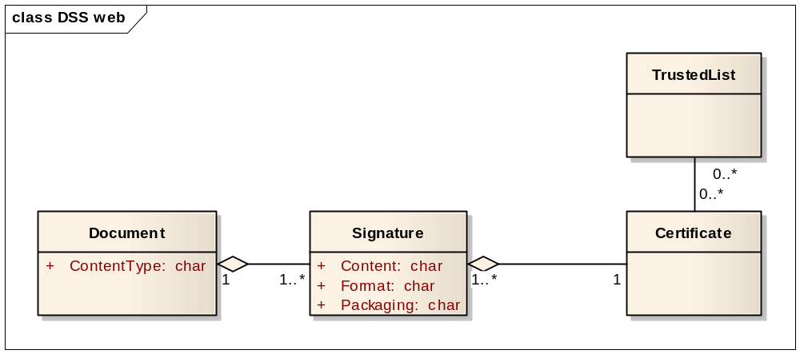
Figure 24: DSS web entities

Document

Attributes
Property | Description
ContentType | This attribute specifies the type of a document. E.g.: XML, …

Associations

Signature
Property | Description
Signature | This association holds the signature which refers to the document. A document can be related to several signatures.

Signature

Attributes
Property | Description
Content | The content of the signature groups all the technical information representing the signature. The syntax and the complexity of this content depend on the format and the packaging method of the signature.
Wrapping | The wrapping method describes how the signature is managed. It can be: Enveloped, enveloping and detached.  The wrapping method depends on the format of the document.
Format | This attribute specifies the format of the signature. E.g.: XAdES-BES, …

Associations

Certificate
Property | Description
SigningCertificate | A signature relies on a signing certificate. This certificate is issued by a certificate service provider.

Certificate

Associations

Trusted List
Property | Description
RelatedTrustedList | A signing certificate can be referenced in one or several trusted list. This association is useful during the verification of the signature of a document.

User interfaces
This section provides a description of user interfaces. The purpose of this section is not to specify user interface mock-ups but to describe specific elements of the user interface.

Trusted List user interfaces

Navigation tree
The system provides a navigation tree allowing a user to navigate through all the entries of the trusted list which are groups in different pages.
The navigation tree reflects the content of the trusted list and evolves in time when the user modifies the working version of trusted list.
Example of the navigation tree structure is:
Trusted list root (TSL information page)
- Pointer to other TSL 1 (Pointer to other TSL page)
- Pointer to other TSL 2 (Pointer to other TSL page)
- TSP 1 (TSP information page)
  - Service 1 (Service current status information page)
    - Service information extension (Service information extension page)
    - Service status history 1 (Service status history page)
      - Service status history information extension (Service information extension page)
  - Service 2 (Service current status information page)
- TSP 2 (TSP information page)

Constraint
This section describes particular behaviours that some fields must respect.

Multilingual field type
Multilingual field is a field for which an actor can give several values depending on a selected language. (See UC-TSL 1.8 – Manage multilingual field).
A multilingual field is composed of:
Field | Type | Description | Constraint | Mandatory
Language tag | Drop down list | The selection of available languages codes.  The content of the list is set in the Trusted list configuration file. |  | Y
Value | Text | The value of the field expressed in the selected language. |  | Y

The following table contains the list of the multilingual fields; all of them must be filled with at least the English value:
Field | English mandatory
Scheme operator name | Y
Scheme operator postal address | Y
Scheme name | Y
Scheme information URI | Y
Policy or legal notice | Y
TSP name | Y
TSP trade name | Y
TSP postal address | Y
TSP information URI | Y
Service name | Y
Scheme service definition URI | Y
TSP service definition URI | Y
Taken over by URI | Y

Multivalued field type
Multivalued field is used for entries that can have multiple values. An actor can give an unlimited number of values for this kind of field. (See UC-TSL 1.9 – Manage multivalued field).
A multivalued field is composed of:
Field | Type | Description | Constraint | Mandatory
Add | Button | Adds a new empty value to the multivalued field. |  | Y
Value | Text | The value of the field. |  | Y

The multivalued fields are the following:
- Scheme operator electronic address
- Scheme type community rule
- TSP Electronic address
- Additional service information
- Policy identifier
- Additional service information

Certificate viewer
The entire certificate information is not displayed in TL Manager for readability. A certificate viewer is provided to allow the presentation of additional certificate information.
In addition, the certificate viewer allows uploading a new certificate in TL Manager.

Field | Type | Description | Constraint | Mandatory
Subject | Text (read only) | Shows the subject of the uploaded certificate |  | Y
Issuer | Text (read only) | Shows the issuer of the uploaded certificate |  | Y
Serial # | Text (read only) | Shows the serial number of the uploaded certificate |  | Y
Key Usages | Text (read only) | Shows the key usage(s) of the uploaded certificate |  | Y
Select certificate | Button | Displays a file picker dialog allowing the selection of a certificate. |  | Y

Complex type
Complex types are composed of several simple fields. These complex types are directly reused in the description of the different pages. The purpose of describing complex types is to avoid repeating the description several times.

Certificate
Field | Type | Description | Constraint | Mandatory
Use for TL | Checkboxes | Allows an actor to specify which certificate information he wants to include in the TL:  - Certificate;  - SubjectName;  - SKI. |  | Y
Distinguished name | Text (read only) | Shows the distinguished name of the uploaded certificates |  | Y
View certificate | Button | Displays the details of the uploaded certificate. |  | Y

Physical address
Field | Type | Description | Constraint | Mandatory
Street address | Text | The street and optionally the street number of the physical address. |  | Y
Locality | Text | The town or the city of the physical address. |  | Y
Postal code | Text | The postal code if applicable. |  | N
State or province | Text | The name of the state or province if applicable. |  | N
Country name | Drop down list | The selection of available country codes.  The content of the list is set in the Trusted list configuration file. |  | Y

Electronic address
Field | Type | Description | Constraint | Mandatory
Address type | Drop down list | Defines the type of electronic address.  The content of the list is set in the Trusted list configuration file. |  | Y
Electronic address | Text | The electronic address. |  | Y

Other Criteria Type
Field | Type | Description | Constraint | Mandatory
Extended key usage | Text | Provides a non-empty list of key purposes values to match with the correspondent “KeyPurposes” present in the “ExtendedKeyUsage” certificate extension | Multiple | N
CertSubjectDNA | Text | Provides identifier that maps to a possible attribute in the subject DN of the certificate. | Multiple | N

Taken Over By extension
Field | Type | Description | Constraint | Mandatory
Critical | Check box | Specifies the criticality of the extension. |  | N
URI | Text | URI pointing towards a descriptive text to inform the user about which entity is currently responsible for the service. |  | Y
TSP name | Text | Specifies the name of the legal entity responsible for the TSP services that are or were recognized by the scheme. | Multilingual | Y
Scheme operator name | Text | The name of the Member State’s body in charge of the TSL. | Multilingual | Y
Scheme territory | Drop down list | The selection of available country codes.  The content of the list is set in the Trusted list configuration file. |  | Y

Additional service information extension
Field | Type | Description | Constraint | Mandatory
Critical | Check box | Specifies the criticality of the extension. |  | Y
Additional information URI | Drop down list | URI identifying the additional information.  The content of the list is set in the Trusted list configuration file. |  | Y
Service information classification | Text | Optional string containing the service information classification. |  | N

ExpiredCertsRevocationInfo Extension
Field | Type | Description | Constraint | Mandatory
Critical | Check box | Specifies the criticality of the extension. | Value= false | Y
Expired Certificates Revocation Information | Date | The time from which on the services issues CRL and/or OCSP responses that keep revocation notices for revoked certificates also after they have expired. |  | Y

TSPInformation Extension
Field | Type | Description | Constraint | Mandatory
Critical | Check box | Specifies the criticality of the extension. |  | Y
Extension | Text | OID identifying the extension of the TSP information. |  | Y

Trusted list edit pages
The trusted list edit pages describe all pages of the system and their content.
Some fields whose value has been fixed in [R02] are not directly editable by an actor and are not presented in the following section.
These particular fields are set in the configuration files.

TSL information page
Field | Type | Description | Constraint | Mandatory
TSL identifier | Text | The identifier of the TSL. |  | N
TSL sequence number | Integer | The sequence number of the TSL starting from “1” at the first release of the TSL. |  | Y
Scheme operator name | Text | The name of the Member State’s body in charge of the TSL. | Multilingual | Y
Scheme operator postal address | Physical address | The physical address of the scheme operator. | Multilingual | Y
Scheme operator electronic address | Electronic address | The electronic address of the scheme operator could be an e-mail or a web-site. At least one of them must be provided. | Multiple | Y
Scheme name | Text | The name which is used in formal reference to the scheme. | Multilingual | Y
Scheme information URI | Text | The path to information describing the general terms and conditions of the scheme. | Multilingual | Y
Scheme type community rule | Text | URI pointing towards a descriptive text where users can obtain information about the scheme and the relevant driving rules and policy. | Multiple | Y
Scheme territory | Drop down list | The selection of available country codes.  The content of the list is set in the Trusted list configuration file. |  | Y
Policy or legal notice | Text | The scheme’s policy or legal notice concerning the legal status of the scheme. | Multilingual | Y
Historical information period | Integer | The number of days for which historical information in the TSL is provided. |  | Y
List issue date | Date | The date and time on which the TSL was issued. |  | Y
Next update | Date | The last date and time by which the next TSL will be issued. |  | Y
Closed | Check box | This check box is related to the “next update” and specifies that the TSL is closed. |  | N
Distribution point | Text | URI specifying location where the current TSL is published. | Multiple | N

Rules
Next update
The fields “Next update” and “Closed” are mutually exclusive. At least one of them must be specified.
If the check box “Closed” is checked, the field “Next update” is set to “0” and cannot be edited.

Pointer to other TSL page
Field | Type | Description | Constraint | Mandatory
Digital ID | Certificate | The issuer of the TSL pointed to. |  | Y
TSL location | Text | Pointer to the location of other TSL. |  | Y
Scheme operator name | Text | The name of the scheme operator for this pointed TSL. | Multilingual | Y
Scheme type community rules | Text | URI pointing towards a descriptive text where users can obtain information about the scheme and the relevant driving rules and policy. |  | Y
Scheme territory | Drop down list | The selection of available country codes.  The content of the list is set in the Trusted list configuration file. |  | Y
Mime type | Drop down list | Specifies the used media type.  The content of the list is set in the Trusted list configuration file and the LOTL configuration file. |  | Y

TSP information page
Field | Type | Description | Constraint | Mandatory
TSP name | Text | Specifies the name of the legal entity responsible for the TSP services that are or were recognized by the scheme. | Multilingual | Y
TSP trade name | Text | Alternative name under which the TSP identifies itself. | Multilingual | N
TSP postal address | Physical address | The physical address of the legal entity. | Multilingual | Y
TSP Electronic address | Electronic address | The electronic address of the legal entity to be used for electronic communication. | Multiple | Y
TSP information URI | Text | Provides a path where users can obtain TSP-specific information | Multilingual | Y
TSP information extension | TSPInformation extension | Provides specific TSP-related information | Multiple | N

Service current status information page
Field | Type | Description | Constraint | Mandatory
Service type identifier | Drop down list | Specifies the identifier of the service type according to the type of the TSL.  The content of the list is set in the Trusted list configuration file. |  | Y
Service name | Text | The name under which the TSP provides the service. | Multilingual | Y
Service digital identity | Certificate | Specifies the digital identifier unique to the service whose type is specified in “Service type identifier”. |  | Y
Service current status | Drop down list | Specifies the identifier of the status of the service.  The content of the list is set in the Trusted list configuration file. |  | Y
Current status starting date | Date | The date and time on which the current approval status became effective. |  | Y
Scheme service definition URI | Text | Specifies where relying parties can obtain service-specific information provided by the scheme operator. | Multilingual | N
Service supply points | Text | Specifies where relying parties can access the service. | Multiple | N
TSP service definition URI | Text | Specifies where relying parties can obtain service-specific information provided by the TSP. | Multilingual | N

Rules
Service current status
If service history is present, the service current status must follow the status flow described in [R02]

Service information extension page
Field | Type | Description | Constraint | Mandatory
Additional service information | Additional service information extension | Extension used to provide additional information about a certain service that may help to verify the applicability of the service. | Multiple | N
Taken over by | Taken Over By extension | Describes the currently responsible TSP when a service was formerly under the responsibility of another TSP. |  | N
Expired Certificates Revocation Information | ExpiredCertsRevocationInfo Extension | Extension indicating the time from which on the service issues CRL and/or OCSP responses that keep revocation notices for revoked certificates also after they have expired. |  | N

Rules
Constraint
A service information extension is not mandatory, but if present, the actor must provide a least one of the four extension types.

Qualification extension page
Field | Type | Description | Constraint | Mandatory
General criticality of all Qualifications in the same Extensions node | Check box | Specifies the criticality of all the qualification extensions. (Shared values) |  | Y
Qualifier 1 | Drop down list | Specifies the properties that has a certificate with the specified criteria.  The content of the list is set in the Trusted list configuration file. |  | Y
Qualifier 2 | Drop down list | Optional qualifier which can be combined with Qualifier 1. |  | N
3 | Drop down list | Optional qualifier which can be combined with Qualifier 1 and 2. |  | N
Assert attribute | Drop down list | Matching criteria indicator selected from the possible value.  The content of the list is set in the Trusted list configuration file. |  | Y
Key usage | Check box | List of key usage value to match with the certificate key usage. (Part of criteria list). |  | N
Policy Identifier | Text | Policy identifier to match with the certificate policy identifier. (Part of criteria list). | Multiple | N
Other Criteria | Other Criteria type | Allows the inclusion of new criteria that can be required by Member States for additional assertions. (Part of criteria list). |  | N

Rules
Criteria list
The criteria list is composed of:
- Key Usage;
- Policy Identifier;
- Other Criteria.
None of this element is mandatory, however, at least one of them must be provided.

Service status history page
Field | Type | Description | Constraint | Mandatory
Service type identifier | Text (Read only) | Specifies the identifier of the service type related to the service. |  | Y
Service name | Text | The name under which the TSP provided the service. | Multilingual | Y
Service digital identifier | Text (Read only) | Displays the distinguished name of the digital identifier related to service. |  | Y
Service previous status | Drop down list | Specifies the identifier of the previous status of the service.  The content of the list is set in the Trusted list configuration file. |  | Y
Previous status starting date | Date | Specifies the date and time on which the previous status became effective. |  | Y

Rules
Service previous status
The service previous status must follow the status flow described in [R02]

New status page
Field | Type | Description |  | Mandatory
Service status | Drop down list | Specifies the identifier of the new status to be used for the service current status.  The content of the list is set in the Trusted list configuration file. |  | Y
Status starting date | Date | The date and time on which the new status becomes effective. |  | Y

Sign TSL page
This page is a wizard in 4 steps. The following table presents the content of the entire wizard.
Field | Type | Description |  | Mandatory
Validation Results | Text | Provides the result of the validation of the Trusted List. | Non-editable | Y
Certificate Source | Radio button | Specifies the available signature means. The following choices are available:  - PKCS#11;  - PKCS#12;  - MS CAPI |  | Y
Signature Method | Text | Provides additional information for singing:  - PKCS#11: signing library;  - PKCS#12: signing certificate (.p12) |  | Y
Certificates | Text | Specifies the signing certificate. | Non-editable | Y
Output | Text | Specifies the destination file of the signed TSL. |  | Y

Supplementary Specifications
This chapter lists technical requirements that are not covered by the Use Case model.

Packaging method
The packaging method applied to the signature of a document is one of the parameters an actor must choose.
However, this method is contextual dependant and relays on the following parameters:
- The type of the document to be signed;
- The selected signature format.
The following table describes the possible choices depending on these parameters:
Document type | Signature format | Packaging method
Document type | Signature format | Enveloped | Enveloping | Detached
PDF | PAdES | X
PDF | XAdES |  | X | X
PDF | CAdES |  | X | X
PDF | ASiC |  | X
XML | XAdES | X | X | X
XML | CAdES |  | X | X
XML | ASiC |  | X
Others | XAdES |  | X | X
Others | CAdES |  | X | X
Others | ASiC |  | X

LOTL management
The list of trusted lists uses the same format as a trusted list. For this reason, no additional functionality must be provided for managing the list of trusted lists and all the use cases describe in section TSL Editing use cases and TSL Management use cases are applicable to the list of trusted lists.
However, since there are differences in parameters between the LOTL and trusted lists, two configuration files are used.
The trusted list management system will be able to manage both kinds of list depending of the used configuration file.

List generation

Trusted list configuration file
The following table defines the trusted list elements coming from the configuration file.
Trusted list element | Configuration file default value
TrustedServiceStatusList TSLTag | http://uri.etsi.org/02231/TSLTag
VersionIdentifier | 4
TSLType | http://uri.etsi.org/TrstSvc/TrustedList/TSLType/EUgeneric
StatusDeterminationApproach | http://uri.etsi.org/TrstSvc/TrustedList/StatusDetn/EUappropriate
SchemeTypeCommunityRules | http://uri.etsi.org/TrstSvc/TrustedList/schemerules/EUcommon  http://uri.etsi.org/TrstSvc/TrustedList/schemerules/EUlistofthelists
Pointer to other TSL – TSL type | http://uri.etsi.org/TrstSvc/TrustedList/TSLType/EUlistofthelists
Mime Type | - application/pdf  - application/vnd.etsi.tsl+xml
Country code | The selection of available country codes (See chapter II in [R01]).
Language code | The selection of available language codes (See chapter II in [R01]).
Address type | - mailto:  - http://  - https://
Service type identifier | - http://uri.etsi.org/TrstSvc/Svctype/CA/PKC  - http://uri.etsi.org/TrstSvc/Svctype/CA/QC  - http://uri.etsi.org/TrstSvc/Svctype/TSA  - http://uri.etsi.org/TrstSvc/Svctype/TSA/QTST  - http://uri.etsi.org/TrstSvc/Svctype/TSA/TSS-QC  - http://uri.etsi.org/TrstSvc/Svctype/TSA/TSS--AdESQCandQES  - http://uri.etsi.org/TrstSvc/Svctype/Certstatus/OCSP  - http://uri.etsi.org/TrstSvc/Svctype/Certstatus/OCSP/QC  - http://uri.etsi.org/TrstSvc/Svctype/Certstatus/CRL  - http://uri.etsi.org/TrstSvc/Svctype/Certstatus/CRL/QC  - http://uri.etsi.org/TrstSvc/Svctype/RA  - http://uri.etsi.org/TrstSvc/Svctype/RA/nothavingPKIid  - http://uri.etsi.org/TrstSvc/Svctype/ACA  - http://uri.etsi.org/TrstSvc/Svctype/SignaturePolicyAuthority  - http://uri.etsi.org/TrstSvc/Svctype/NationalRootCA-QC  - http://uri.etsi.org/TrstSvc/Svctype/Archiv  - http://uri.etsi.org/TrstSvc/Svctype/REM  - http://uri.etsi.org/TrstSvc/Svctype/EDS  - http://uri.etsi.org/TrstSvc/Svctype/EDS/Q  - http://uri.etsi.org/TrstSvc/Svctype/PSES  - http://uri.etsi.org/TrstSvc/Svctype/PSES/Q  - http://uri.etsi.org/TrstSvc/Svctype/IdV  - http://uri.etsi.org/TrstSvc/Svctype/KEscrow  - http://uri.etsi.org/TrstSvc/Svctype/PPwd  - http://uri.etsi.org/TrstSvd/Svctype/TLIssuer  - http://uri.etsi.org/TrstSvc/Svctype/unspecified
Service status | - http://uri.etsi.org/TrstSvc/TrustedList/Svcstatus/undersupervision;  - http://uri.etsi.org/TrstSvc/TrustedList/Svcstatus/supervisionincessation;  - http://uri.etsi.org/TrstSvc/TrustedList/Svcstatus/supervisionceased;  - http://uri.etsi.org/TrstSvc/TrustedList/Svcstatus/supervisionrevoked;  - http://uri.etsi.org/TrstSvc/TrustedList/Svcstatus/accredited;  - http://uri.etsi.org/TrstSvc/TrustedList/Svcstatus/accerditationceased;  - http://uri.etsi.org/TrstSvc/TrustedList/Svcstatus/accreditationrevoked.
Qualifier | - http://uri.etsi.org/TrstSvc/TrustedList/SvcInfoExt/QCWithSSCD;  - http://uri.etsi.org/TrstSvc/TrustedList/SvcInfoExt/QCNoSSCD;  - http://uri.etsi.org/TrstSvc/TrustedList/SvcInfoExt/QCSSCDStatusAsInCert;  - http://uri.etsi.org/TrstSvc/TrustedList/SvcInfoExt/QCForLegalPerson;  - http://uri.etsi.org/TrstSvc/TrustedList/SvcInfoExt/QCStatement.
Assert attribute | - all  - atLeastOne  - none
Key usage | - Digital signature  - Non repudiation  - Key encipherment  - Data encipherment  - Key agreement  - Key CertSign  - CRL signature  - Encipher only  - Decipher only
Additional service information URI | - http://uri.etsi.org/TrstSvc/SvcInfoExt/RootCA-QC;

Remark
The tag “SchemeTypeCommunityRules” requires two distinct URI:
- A common fixed URI (http://uri.etsi.org/TrstSvc/TrustedList/schemerules/EUcommon);
- and a Member State specific URI http://uri.etsi.org/TrstSvc/TrustedList/schemerules/CC where the parameter “CC” must be equal to the provided “Scheme territory”.
The business rules specified in this document concern only the following service type identifiers:
- http://uri.etsi.org/TrstSvctype/CA/PKC;
- http://uri.etsi.org/TrstSvctype/CA/QC;
- http://uri.etsi.org/TrstSvctype/CA/TSA;
- http://uri.etsi.org/TrstSvctype/CertStatus/OCSP;
- http://uri.etsi.org/TrstSvctype/CertStatus/CRL.

LOTL configuration file
The following table defines the LOTL elements coming from the configuration file.
In particular, since no TSP and by extension no service are required for the LOTL, all the corresponding parameters are not used.
LOTL element | Configuration file default value
TrustedServiceStatusList TSLTag | http://uri.etsi.org/02231/TSLTag
VersionIdentifier | 4
TSLType | http://uri.etsi.org/TrstSvc/TrustedList/TSLType/EUlistofthelists
Pointer to other TSL – TSL type | http://uri.etsi.org/TrstSvc/TrustedList/TSLType/EUgeneric
Mime Type | - application/pdf  - application/vnd.etsi.tsl+xml
Country code | The selection of available country codes (See chapter II in [R01]).
Language code | The selection of available language codes (See chapter II in [R01]).
Address type | - mailto:  - http://  - https://

TSL signature
This section describes the xml structure of the trusted list signature. This signature is compliant with [R02].
The variable parts of this signature that will be computed during the signature process are the following:
Signature element | Description
Trusted list reference URI | The local path to the identifier of the trusted list in the current xml file.  Example: #TrustServiceStatusList-1
Trusted list reference DigestValue | The base64 encoded value of the digest computed on the trusted list.
SignedProperties Reference DigestValue | The base64encoded value of the digest computed on the signed properties.
SignatureValue | The actual base64encoded value of the digital signature.
KeyInfo X509Certificate | The base64encoded value of the X509 signing certificate.
SingningTime | The signing time expressed in Zulu format.
SingningCertificate DigestValue | The base64encoded value of the digest computed on the DER-encoded certificate.
X509IssuerSerial | The list of couple (X509IssuerName, X509SerialNumber) representing the certificates chain.
X509IssuerName | The distinguished name of the issuer of the X509 signing certificate.
X509SerialNumber | The serial number of the X509 signing certificate.
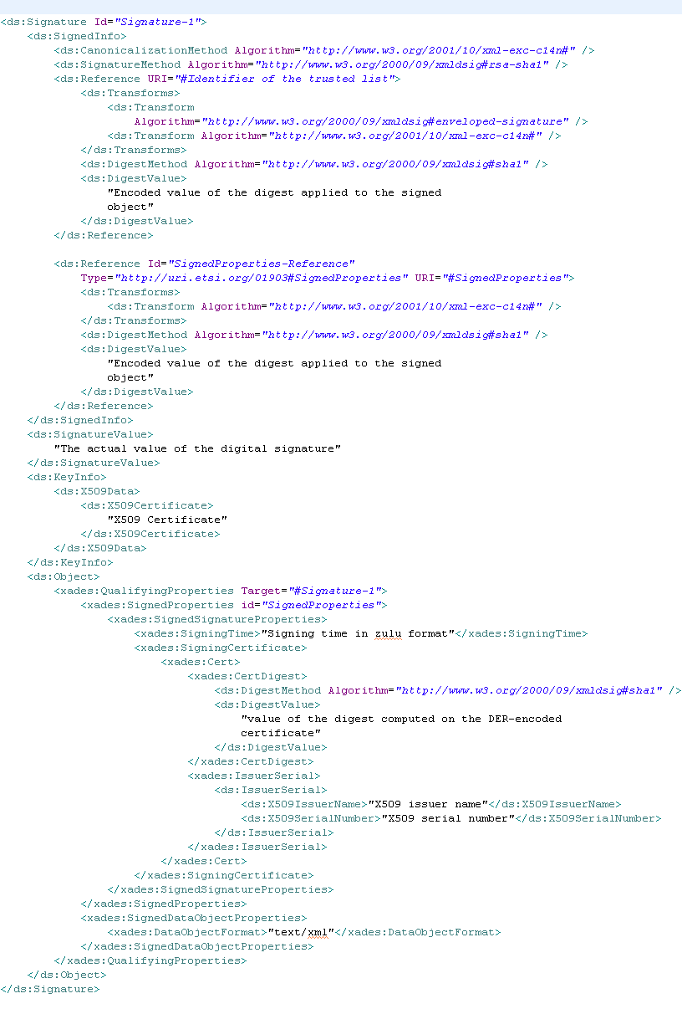
Figure 25: Trusted list signature

DSS Web profiles
This section introduces common sets of options (so called profiles) that must be taken into account according to the level of signature intended to be reached.
Several profiles are proposed depending on the signature format: XAdES, CAdES, PAdES and ASiC, and are the result of analysis based on [R04], [R05] and [R06]. Optional attributes that are not included in those profiles are not intended to be managed.
These profiles are intended to be deeply detailed in further work and will be based on [R12], [R13] [R14] and [R15].

Compliance requirements
Profiles in the present document define separated requirements for both generator and verifier of signatures. Requirements are grouped in three different categories.
Identifier | Requirement on generator | Requirement on verifier
M | Generator shall include the element in the signature. | Verifier shall process the element.
R | Generator should include the element in the signature. | Verifier shall process the element if present.
O | Generator may include the element in the signature. | Verifier may either process or ignore this element and process the rest of the signature.

Configuration file
Some required parameters must be provided for each instance of the DSS web system. These parameters must be set in a configuration file that can be edited by the administrator of each instance.
With this behaviour, the important parameters are not selected by the end user of the system but configured on the server side.
Each Member State can define at a national level which parameters must be used to meet the requirements of Commission and national laws.
The configuration file must contain at least the following parameters:
- XAdES canonicalization method
- XAdES digest method
- CAdES digest method
- PAdES digest method
- Signature method
- TSP server (time stamp)
- LOTL signing certificate
- LOTL URL
The available values for these parameters are described in the different profiles shown in the following section.
Additional requirement:
- By default the system uses the RSA-PSS signature method.

Multiple signature
Several signatures can refer to a document. As mentioned in section UC-DSS 1.1 – Sign a document, an actor can successively sign a document with several signatures.
Such a use of the functionality results on the creation of several signatures “objects” managed as follows according to the format of the signatures.

X/CAdES and ASiC format
In these formats multiple signatures are managed as parallel signatures. Each signature signs the content of the document without relation with the others.
This behaviour means that all signatures have the same weight and can be applied without priority. In addition the number of signatures is unbound; the system will not provide any control.

PAdES format
PDF document cannot be signed with parallel signatures and must use sequential signatures.
Each signature signs the content of the document and the previous signature content.
However it is not in the scope of the system to perform a control on the number and the order of the multiple signatures.

XAdES profile

Placement of the signature
Signature element | Generator requirement | Verifier requirement | Additional requirement
Service: signature | M | M
Enveloping signature | O | R
Enveloped signature | O | R
Detached signature | O | R

Canonicalization method, signature method and digest method
The choice of the following method has been based on the analysis of the trusted list implementation.
Signature element | Generator requirement | Verifier requirement | Additional requirement
ds:CanonicalizationMethod | M | M
xml-exc-c14n# | O | R
REC-xml-exc-c14n-20010315 | O | R
xml-c14n11 | O | R
ds:SignatureMethod | M | M
RSA | O | R
DSA | O | R
ECDSA | O | R
ds:DigestMethod | M | M
xmlenc#sha256 | O | R
xmldsig#sha1 | O | R

Transforms
Signature element | Generator requirement | Verifier requirement | Additional requirement
ds:Transform | M | M
Canonicalization transforms | M | M | See section 5.4.4.2
Enveloped signature transforms | O | R
Base64 encoding | O | R
Filtering | O | R
XSLT transforms | O | R

Profile of elements in XAdES-BES/EPES

Ds:KeyInfo and xades:SigningCertificate
Service / Signature element | Generator requirement | Verifier requirement | Additional requirement
Service: Identifying signer and validation key and securing the signing certificate | M | M
ds:KeyInfo/X509Data/X509Certificate present | M | M | 1
xades:SigningCertificate present | M | M | 2

Additional requirements:
- For facilitating the validation process, the signer’s certificate chain is recommended to be provided up to the certificate issuer declared in the national trusted list.
- SigningCertificate must contain the digest value of the signer’s certificate stored in ds:KeyInfo and match description in [R03].

Signing time
Service / Signature element | Generator requirement | Verifier requirement | Additional requirement
xades:SigningTime | M | M

Signature policy identifier
Service / Signature element | Generator requirement | Verifier requirement | Additional requirement
xades:SignaturePolicyIdentifier | O | R | 1, 2

Additional requirements:
- The SignaturePolicyIdentifier may be used by the generator according the XAdES-EPES specifications [R03].
- The optional “SignaturePolicyIdentifier” can be provided in a human readable format. Automatic processing is out of the scope of the current project.

Signer role
Service / Signature element | Generator requirement | Verifier requirement | Additional requirement
xades:ClaimedRole | O | R

Additional attributes for XAdES-T
XML Advanced Electronic Signature with Time (XAdES-T) is a signature for which there exists a trusted time associated to the signature.

Signature time-stamp
Service / Signature element | Generator requirement | Verifier requirement | Additional requirement
xades:SignatureTimeStamp | M | M

Additional attributes for XAdES-C
XML Advanced Electronic Signature with Complete validation data references (XAdES-C) adds to XAdES-T the “completeCertificateRefs” and “completeRevocationRefs” unsigned properties.

Certificate references
Service / Signature element | Generator requirement | Verifier requirement | Additional requirement
xades:CompleteCertificateRefs | M | M

Revocation status references
Service / Signature element | Generator requirement | Verifier requirement | Additional requirement
Service: complete revocation status references | M | M
xades:CompleteRevocationRefs/  CRLRefs | O | R | 1
xades:CompleteRevocationRefs/OCSPRefs | O | R | 1

Additional requirement:
- The generator is recommended to use the service, using either CRLs or OCSPs responses. The verifier should be able to handle both.

Additional attributes for XAdES-X
Extended signatures with time indication forms (XAdES-X) build on XAdES-C by adding one or more time-stamps properties. Depending on what the time stamp applies, the format is XAdES-X type 1 or XAdES-X type 2. This choice is set at the creation time according to the configuration parameters.

Time indication
Service / Signature element | Generator requirement | Verifier requirement | Additional requirement
Service: extended signatures with time indication | M | M
xades:SigAndRefsTimeStamp | O | R | 1
xades:RefsOnlyTimeStamp | O | R | 1

Additional requirement:
- Depending on what is time-stamped the generator may use either XAdES-X type 1 or type 2. The verifier should be able to handle both.

Additional attributes for XAdES-X-L
Extended Long electronic signatures with time forms (XAdES-X-L) build on XAdES-X type 1 or 2 by adding the “CertificateValues” and “RevocationValues” unsigned properties.

Certificate and revocation values
Service / Signature element | Generator requirement | Verifier requirement | Additional requirement
xades:UnsignedProperties/ CertificateValues | M | M | 1
xades:UnsignedProperties/ RevocationValues | M | M | 2
xades:CRLValues | O | R
xades:OCSPValues | O | R

Additional requirements:
- The unsigned property “CertifcateValue” is used by the generator to provide the certificate chain to facilitate the validation process. In that case, the chain must not be given in ds:KeyInfo anymore (see section 5.4.4.4.1).
- All revocation data referenced in RevocationRefs must be present in the RevocationValues property.

Additional attributes for XAdES-A
Service / Signature element | Generator requirement | Verifier requirement | Additional requirement
Service: Archival electronic signature
xadesv141:ArchiveTimeStamp | M | M | 1

Additional requirement:
- Archival signature incorporates one or more “xadesv141:ArchiveTimeStamp” unsigned properties. Each “xadesv141:ArchiveTimeStamp” element contains time-stamp tokens covering among other elements, those ones that contain validation data.

CAdES profile

Placement of the signature
Signature element | Generator requirement | Verifier requirement | Additional requirement
Service : signature | M | M
Enveloping with data | R | R
Detached signature | O | R

Signature and digest method
Signature element | Generator requirement | Verifier requirement | Additional requirement
Message digest | M | M
sha-256 | O | R
sha-1 | O | R
Signature algorithm | M | M
RSA | O | R
DSA | O | R
ECDSA | O | R

Profile of elements in CAdES-BES/EPES

Content type
Service / Signature element | Generator requirement | Verifier requirement | Additional requirement
eContentType | M | M | 1

Additional requirement:
- The ContentType must be present and set to “id-Data”.

Signer identifier
Service / Signature element | Generator requirement | Verifier requirement | Additional requirement
Sid | O | O | 1

Additional requirement:
- The signer identifier is optional since the certificate’s issuer and the serial number must be present in the signed attributes.

Signing certificates
Service / Signature element | Generator requirement | Verifier requirement | Additional requirement
Service: Identifying signer and validation key
SignedData.certificates | M | M | 1

Additional requirement:
- For facilitating the validation process, the signer’s certificate chain is recommended to be listed up to the certificate issuer declared in the national trusted list.

Signing time
Service / Signature element | Generator requirement | Verifier requirement | Additional requirement
signing-time | M | M

Signed attributes
Service / Signature element | Generator requirement | Verifier requirement | Additional requirement
Content type
id-ContentType | M | M
Message digest
id-messageDigest | M | M
Service: protection of signing certificate | M | M | 1
ESS signing-certificate | O | R
ESS signing-certificate v2 | O | R
Claimed role
claimedAttributes | O | R

Additional requirement:
- The signed attributes must contain a reference to the signer’s X509 v3 digital certificate either in the attribute “ESS signing-certificate” or in “ESS signing-certificate v2” depending on the digest algorithm.

Signature policy identifier
Service / Signature element | Generator requirement | Verifier requirement | Additional requirement
sigPolicyId | O | R | 1

Additional requirements:
- The SignaturePolicyIdentifier may be used by the generator according to CAdES-EPES specifications [R07].
- The optional “sigPolicyId” can be provided under a human readable format. Automatic processing is out of the scope of the current project.

Additional attributes for CAdES-T
Electronic signature with time (CAdES-T) means, when a trusted time stamp is associated to the electronic signature.

Signature time-stamp
Service / Signature element | Generator requirement | Verifier requirement | Additional requirement
signature-time-stamp | M | M

Additional attributes for CAdES-C
Electronic signature with complete validation data references (CAdES-C) adds to CAdES-T attributes the “complete-certificate-references” and “complete-revocation-references” attributes.

Certificate references
Service / Signature element | Generator requirement | Verifier requirement | Additional requirement
complete-certificate-references | M | M

Revocation status references
Service / Signature element | Generator requirement | Verifier requirement | Additional requirement
Service: complete revocation status references | M | M
complete-revocation-references.crlids | O | R | 1
complete-revocation-references.ocspids | O | R | 1

Additional requirement:
- The generator is recommended to use the service, using either CRLs or OCSPs responses. The verifier should be able to handle both.

Additional attributes for CAdES-X
Extended format with time (CAdES-X) adds to CAdES-C time stamp attribute:
- Type 1: on the CAdES-C itself;
- Type 2: on the certification and revocation references.

Time indication
Service / Signature element | Generator requirement | Verifier requirement | Additional requirement
Service: extended signatures with time indication | M | M
CAdES-C-time-stamp | O | R | 1
CAdES-C-time-stamped-certs-crls-references | O | R | 1

Additional requirement:
- Depending on what is time-stamped the generator may use either CAdES-X type 1 or type 2. The verifier should be able to handle both.

Additional attributes for CAdES-X Long
Extended long format (CAdES-X Long) adds the “certificate-values” and “revocation-values” attributes to the CAdES-C format.

Certificate and revocation values
Service / Signature element | Generator requirement | Verifier requirement | Additional requirement
certificate-values | M | M | 1
Service: revocation status values | M | M | 2
revocation-values.crlVals | O | R
revocation-values.ocspVals | O | R

Additional requirements:
- The unsigned attribute “certificate-Values” may be used by the generator to provide the certificate chain to facilitate the validation process IF this chain is not provided in “SignedData.certificates” (see section 5.4.5.3.3).
- A verifier should be able to process a CRL and an OCSP Responses regardless of where it fetches the revocation status information.

CAdES-X-Long type 1 and type 2
Extended long with time (CAdES-X Long Type 1 or 2) is a combination of CAdES-X Long with one of the two CAdES-X Type 1 and CAdES-X Type 2.

Additional attributes for CAdES-A
Archival Form (CAdES-A) built by adding one or more “archive-time-stamp” attributes.
Service / Signature element | Generator requirement | Verifier requirement | Additional requirement
archive-time-stamp | M | M

PAdES profile
Requirements for handling PDF Signatures specified in clause 12.8 of [R08] apply except where overridden by the present profile.

Placement of the signature
Signature element | Generator requirement | Verifier requirement | Additional requirement
Service : signature | M | M
Enveloped | M | M

Signature and digest method
Signature element | Generator requirement | Verifier requirement | Additional requirement
Message digest
sha-1 | M | M
Signature algorithm | M | M
RSA | O | R
DSA | O | R
ECDSA | O | R

Profile of elements in PAdES-BES/EPES
Signature Dictionary entry | Generator requirement | Verifier requirement | Additional requirement
SubFilter | M | M | 1
Content | M | M | 2
CAdES.signature-time-stamp | O | R
M | M | M | 3
ByteRange | M | M | 4

Additional requirements:
- Shall contain “ETSI.CAdES.detached”.
- The key “Content” includes a DER-encoded SignedData object forming a CAdES-BES/EPES signature. See the section Profile of elements in CAdES-BES/EPES.
- The time of signing is indicated by the value of the M key in the signature dictionary instead of in the CAdES.signing-time.
- The ByteRange shall cover the entire file, including the signature dictionary but excluding the PDF signature itself.

Additional attributes for PAdES-LTV
This profile format adds to the PAdES-BES/EPES:
- A Document Security Store to carry the validation data;
- A Document Time-stamp.

Document Security Store entries
Service / DSS Dictionary entry | Generator requirement | Verifier requirement | Additional requirement
VRI | O | R
Certs | M | M
Service : revocation status values | M | M | 1
CRLs | O | R
OCSPs | O | R

Additional requirement:
- A verifier should be able to process a CRL and an OCSP Responses regardless of where it fetches the revocation status information.

Document Time-stamp entries
Service / DSS Dictionary entry | Generator requirement | Verifier requirement | Additional requirement
Type | M | M | 1
SubFilter | M | M | 2
Content | O | R

Additional requirements:
- Shall be “DocTimeStamp”.
- Shall be “ETSI.RFC.3161”.

ASiC profile
The ASiC profile allows to sign a single file a a time, as proposed in ASiC-S. If more than one file has to be signed, the specification [R09] proposes to collect these files in a ZIP before signing with ASiC-S.
The signature format within ASiC will be XAdES signature format (see [R09], “5.1 General Requirements for ASiC-S”).
The signature packed in the ASiC container will follow 5.4.4 - XAdES profile, except for the placement of the signature.

Placement of the signature
ASiC signature is always enveloped signature.
Signature element | Generator requirement | Verifier requirement | Additional requirement
Service : signature | M | M
Enveloped | M | M

Validation algorithm
The validation algorithm implemented by SD-DSS, is that proposed by ETSI TS 102 853 standard. For a detailed description of this process and its sub processes please refer to the [18].

Description
The SD-DSS framework validates an electronic signature against a set of validation constraints and outputs a simple validation report. This report consists of a status indication (i.e. VALID, INVALID or INDETERMINATE) accompanied by sub-indications (i.e. OUT_OF_BOUNDS_NO_POE, HASH_FAILURE…) and by additional data items. The report may include additional information (e.g. explanations and other information to be displayed) that has been found relevant.
To give an overview of the validation process please find below a macroscopic explanation.
In order to produce the simple validation report with this information, the validation algorithm can be broken down into several steps:
- Signed document analysis including:
  - Information extraction (certificates, OCSP responses, timestamps…);
  - Static information validation (references, digests, signatures…);
  - Certification path building;
  - Dynamic data retrieval (OCSP, CRL, AIA, TrustedList);
  - Diagnostic data generation.
- Loading validation policy (constraints).
- Execution of the validation processes taking into account the diagnostic data and constraints:
  - Basic building blocks process;
  - Basic validation process;
  - Timestamps validation process;
  - AdES-T validation process;
  - Long-term validation process.
- Production of the simple validation report.
NOTE 1: The validation process must also implement the certification path and revocation data analysis and trusted list analysis. These algorithms are not a part of ETSI standard [19]; that is why their description follows.

Certification Path and Revocation Data analysis
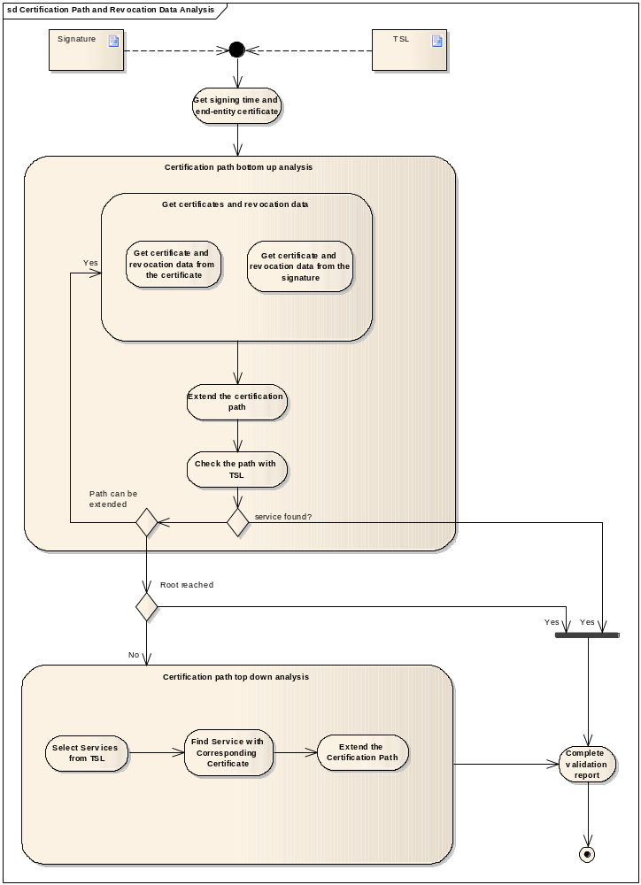
Figure 26: Certification path and revocation data analysis

ASSUMPTION
The first step of the algorithm is the construction of the certification path up to a service in a trusted list.
In theory, it could be possible that this certification path leads to several services from different trusted lists.
For convenience, the assumption was made that the algorithm is successful once it finds the first service available.
This assumption was made taking into account that:
- This behaviour covers the majority of the cases;
- The verification of the synchronisation of the services’ status between the different trusted lists is out of the scope of this algorithm.

Description
The certification path must be built from the end-entity certificate up to a trusted issuer. According to the definition of a trusted list, there is no need to build the certification path up to a trust anchor as a path up to a trusted list is sufficient condition to trust an issuer.
By default, the applicable trusted list is the one from the identified Member State in which the issuer of the end-entity certificate is established as this Member State is in charge of supervising the issuing CA service.
The construction of this path is an iterative process which, starting from the end-entity certificate, will validate each certificate issuer, one after another, until a trusted issuer can be found in a trusted list.
At each step of the certification path construction, the revocation data could not be verified because:
- The revocation data are not available;
- The issuer of the revocation data cannot be verified.
This should not be a condition to stop the certification path analysis, the algorithm must continue and a warning will be added to the validation report.
The list of certificates and revocation data required to build this certification path can be found from 3 sources:
- The signature;
- The certificate;
- The trusted list.

Get signing time and end-entity certificate
The first action to perform is to get the signature signing time and the end-entity certificate.
The end-entity certificate must be used as the starting point of the certification path.
The signing time is required information, as a reference time, to guarantee that the certification path is checked according to the appropriate date and time, i.e. is valid at the time of the signature.
According to [R06], the signing time should be mandatory. Nevertheless, if this information is missing, the validation algorithm must use another reference time as close as possible of the effective signing time.
In such a case, the validation algorithm must use one the following reference time ordered by priority:
- If present, time stamp from signature signed properties;
- If present, time stamp from signature unsigned properties;
- If no time indication is present in the signature, the time of the validation.
For solution 2 and 3, the reference time could potentially be too far of the effective signing time. For this reason, the validation report must contain a statement to warn of this risk.

Certification path bottom-up analysis
Most of the time, the length of the certification path is equal to 1, i.e. the end-entity certificate can directly be found in a trusted list.
If it is not the case, the signature and/or the certificates themselves should contain enough information to find a match in the trusted list so that a bottom-up analysis is sufficient.
This analysis will be performed through the following steps:
- Get the parent certificate, and revocation data allowing to check the validity of the certificate;
- Check if the path leads to a service from the trusted list;
These steps are recursively used until
  - A matching service can be found
  - The path cannot be updated because of a lack of information or leads to a root certificate, but the path does not lead to the trusted list.

Get certificates and revocation data
During the bottom-up analysis, certificates and revocation data can be retrieved either from the signature itself either or from the current certificate information.

Get certificates and revocation data from signature
Ideally, the signature should contain the list of certificates required to build the certification path and potentially the related revocation data which can be used to verify the validity of the certificate.
The algorithm will then analyse the signature as first source of information.

Get certificates and revocation data from certificate
At least a certificate should contain a reference to the revocation data needed to verify its validity. In addition, it does also contain a reference to its direct issuer.
The algorithm must analyse the certificate to complete the set of information required to build and validate the certification path.

Extend the Certification path
The certification path is built upon the certificates and the revocation data retrieved from 5.5.1.1.4.1.
- The end-entity certificate is the first element of the path;
- The revocation data are verified to confirm the validity of the certificate from its issuer.

Check the path with TSL
At each iteration of the bottom-up analysis, the algorithm must check if the current certification path leads to the trusted list.
To perform this verification, the set of services in the trusted list is filtered using the following information:
- The signing / reference time of the algorithm;
- Only CA/QC and CA/PKC services and service history entries must be considered;
The algorithm must then find a match between the certification path and the set of filtered services:
- Either the SDI of a service referenced in the trusted list matches the issuer of a certificate from the certification path;
- Either the SDI of a service referenced in the trusted list directly matches a certificate from the certification path.
In particular, if historical information are present in the matching service, the signing / reference time is used to retrieve the appropriate history entry.

Matching service
For each matching service, the following information is extracted:
- The TSP information
  - Name;
  - TradeName (English version);
  - Postal address (English version);
  - Electronic address (English version);
- The service information
  - Service type identifier;
  - Name;
  - Status information:
    - Current status;
    - Current status starting date;
    - Status at reference time;
    - Status starting date at reference time;
  - Additional service information;
  - Service information extension: Qualifications;
  - Taken over by information:
    - URI;
    - TSP Name (English version);
    - Scheme operator name (English version);
    - Scheme territory (English version).

No matching service
If no service or TSP of the trusted list can be related to the current certification path, the algorithm will start a new iteration, i.e. get certificate and revocation data and build the next level of the certification path.
The certification path could potentially not be extended anymore for 2 reasons:
- The root CA has been reached, in that case the algorithm cannot match the certification path with the trusted list;
- Intermediate CA certificates are missing, in that case the algorithm will try a top-down analysis.

Certification path top-down analysis
A particular case occurs when a Member State decides to use the certificate of a Root or upper level CA as the SDI of a single entry in the list of services from a listed TSP.
This CA does not directly issue end-entity QCs but certify a hierarchy of CAs down to CAs issuing QCs. In this situation the trusted list should provide the missing information about the intermediate CA certificates.
This analysis must verify if the trusted list contains the references to the missing intermediate CA certificates and, if present, try to match them with the certification path that has been built so far.

Select Services from TSL
The algorithm must find the appropriate trusted service provider from the trusted list. To do so, the following actions are performed:
- Select all services or service history entries whose type is CA/QC with an “Root CA” ASI extension;
- Select all services or service history entries that provide intermediate CA certificates information.
In particular, if historical information are present in the matching service, the signing / reference time is used to retrieve the appropriate history entry.

Find Service with Corresponding Certificate
The set of services previously selected from the trusted list must be analysed to find a match between the current certification path and the intermediate CA certificates found in those services.
If such a match can be found, the certification path can be updated using the certificates provided in the service information.
If no service with corresponding certificate can be found, the certification path cannot be completed.

Extend the certification path
For each service with corresponding certificates, the certification path is built and the revocation data are checked.
The following information is extracted:
- The TSP information
  - Name;
  - Trade Name (English version);
  - Postal address (English version);
  - Electronic address (English version);
- The service information
  - Service type identifier;
  - Name;
  - Status information:
    - Current status;
    - Current status starting date;
    - Status at reference time;
    - Status starting date at reference time;
  - Additional service information:
  - Service information extension: Qualifications;
  - Taken over by information:
    - URI;
    - TSP Name (English version);
    - Scheme operator name (English version);
    - Scheme territory (English version).

Complete the validation report
The validation report must be completed with:
- The information from all certificates and revocation data (including the end-entity certificate);
- TSP and service information to which the certification path leads.

Trusted List Analysis
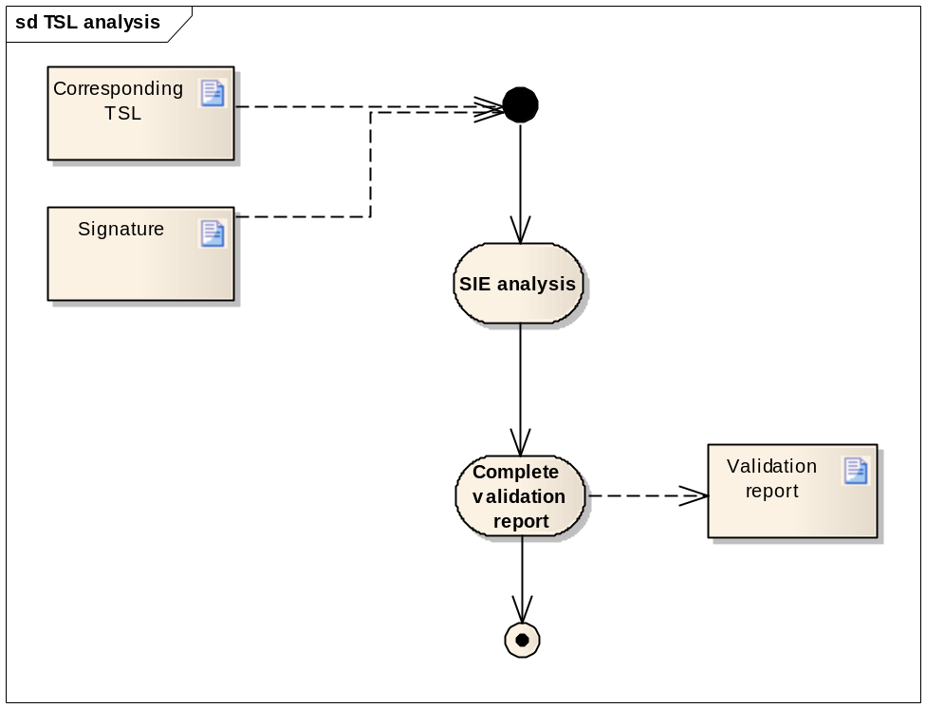
Figure 27: Trusted list analysis

Description
The aim of the analysis of the trusted list is to find information whether or not the signature is AdES, AdES_{qc} or QES.
In particular, the algorithm checks the presence and the content of the Service Information Extension of the trusted list.

SIE analysis
The algorithm must
- Check the presence of the tag “ecc:Qualifications”;
- For each “QualificationElement”
  - Check if the end-entity certificate match the criteria list taking into account the asset (At least one, All, None) attribute:
    - Policy identifier must correspond;
    - Key usage must correspond;
    - Other criteria must correspond;
  - If correspondence can be found, the criticality and the list of qualifiers of the QualificationElement is extracted:

Certificate Content Analysis

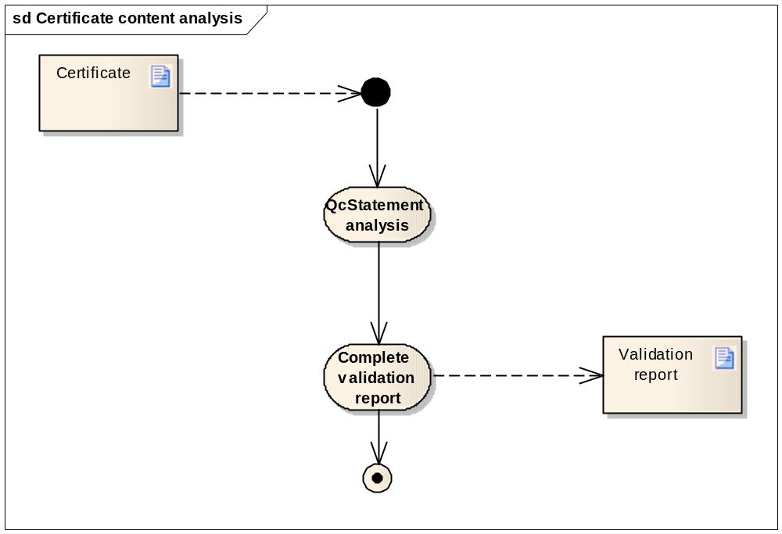
Figure 28: Certificate content analysis

Description
As the analysis of the trusted list, the analysis of the content of the certificate provides potential information whether or not the signature is AdES, AdES_{qc} or QES.
The algorithm must check the certificate extensions providing information on qualifying compliance.

QcStatement analysis
The validation algorithm must analyse certificate extensions and in particular the qualified certificate statements:
- Check the presence of the ETSI defined QCP(+) OID;
- Check the presence of the QcStatement:
  - QcCompliance;
  - QcSSCD.

Complete validation report
For each qualified certificate statement found in the certificate, the following information must be depicted in the validation report:
Statement | Presence
QCP | True/false
QCP+ | True/false
QCCompliance | True/false
QCCompliance +  QcSSCD | True/false
Table 4: Example of certificate content analysis report format

The strength of the signature
The strength of the signature must determine whether or not the end-entity certificate is qualified and whether the signature is AdES, AdES_{qc} or QES.
This information is inferred from both trusted list analysis and certificate content analysis.
The following table describes the possible conclusions of the validation algorithm.
1=QES  2=AdES_{QC}  3=AdES | *=no TL confirmation from MS where CSP/CA is established  **=no TL confirmation as MS TL where CSP/CA is established is not available  ***=TL confirmation but TL not signed or TL verification cert not in LOTL | Certificate content
1=QES  2=AdES_{QC}  3=AdES |  | QCP only | QCP  + QcC | QCP  + QcC  +QcSSCD | QCP+ only | QCP+  + QcC | QCP+  + QcC  +QcSSCD | QcC only | QcSSCD  only | QcC  + QcSSCD | No machine processable info (+)
TL content | Cert covered by CA/QC | 2 | 2 | 1 | 1 | 1 | 1 | 2 | 3 | 1 | 3
TL content | Cert covered by CA/QC  + QCWithSSCD | 1 | 1 | 1 | 1 | 1 | 1 | 1 | 3 | 1 | 3
TL content | Cert covered by CA/QC  + QCNoSSCD | 2 | 2 | 2 | 2 | 2 | 2 | 2 | 3 | 2 | 3
TL content | Cert covered by CA/QC  + QCSSCDAsInCert | 2 | 2 | 1 | 1 | 1 | 1 | 2 | 3 | 1 | 3
TL content | Cert covered by CA/QC  + QCForLegalPerson | 2 | 2 | 1 | 1 | 1 | 1 | 2 | 3 | 1 | 3
TL content | Cert not covered by CA/QC | 2* | 2* | 1* | 1* | 1* | 1* | 2* | 3* | 1* | 3*
TL content | Trusted List not available | 2** | 2** | 1** | 1** | 1** | 1** | 2** | 3** | 1** | 3**
TL content | TL available but not signed or TL verification cert not in LOTL | 2*** | 2*** | 1*** | 1*** | 1*** | 1*** | 2*** | 3*** | 1*** | 3***
Table 5: Final conclusion matrix
indicates a conflict between certificate content and Trusted List content
Strictly speaking a cert with QcSSCD only (no QcC statement set) should not be considered as a QC

Validation Constraints and Validation policy
Validation policy is materialized by a set of constraints that are applied to cryptographic data during the execution of the signature validation process. Constraints are stored in an XML file what allows their easy handling. The SD-DSS framework through its demo application provides a graphical interface for handling these constraints. Below is the list of constraints that can be (are) used in the validation process.
- <ConstraintsParameters Name="QES AdESQC TL based">
This element is the name of the policy

- <Description>Validate electronic signatures…</Description>
This element is the description of the validation policy

- <RevocationFreshness Unit="DAYS">0</RevocationFreshness>
This element if present indicates the revocation freshness for the certificates validation. If its value is 0 then the revocation freshness is not checked. This parameter applies to all certificates.

- <TimestampDelay Unit="DAYS">0</TimestampDelay>
This element indicates a maximum acceptable delay between the signing time as claimed by the signer and the time included within the signature Timestamp (i.e. AdES-T).

- <AlgoExpirationDate Format="yyyy-MM-dd">
<Algo Name="SHA1">2017-02-24</Algo>
<Algo Name="SHA256">2035-02-24</Algo>
<Algo Name="RSA">2017-02-24</Algo>
<Algo Name="DSA">2017-02-24</Algo>
<Algo Name="ECDSA">2035-02-24</Algo>
</AlgoExpirationDate>
An expiration date: This date specifies, until when the given algorithm/key size or algorithm/hash length combination is accepted as being strong enough.

- Cryptographic constraints are applied on algorithms and parameters used when validating signed objects included in the validation process (e.g. signature, certificates, CRLs, OCSP responses, time stamps):
<SignatureToValidate>
<SigningCertificate>
<CACertificate>
<TimestampCertificate>
<OCSPCertificate>
<CRLCertificate>

- They are represented by a list of entries, each consisting of:

<AcceptableEncryptionAlgo>
<Algo>RSA</Algo>
<Algo>DSA</Algo>
<Algo>ECDSA</Algo>
</AcceptableEncryptionAlgo>
<MiniPublicKeySize>
<Size Algo="RSA">1024</Size>
<Size Algo="DSA">128</Size>
<Size Algo="ECDSA">256</Size>
</MiniPublicKeySize>
<AcceptableDigestAlgo>
<Algo>SHA1</Algo>
<Algo>SHA256</Algo>
<Algo>MD5</Algo>
</AcceptableDigestAlgo>
<QualifiedCertificate>true</QualifiedCertificate>
<SSCD>true</SSCD>
<ForLegalPerson>false</ForLegalPerson>

- <MandatedSignedQProperties>
<SigningTime>true</SigningTime>
<CommitmentTypeIndication>false</CommitmentTypeIndication>
<SignerLocation>false</SignerLocation>
This element indicates the mandated signed qualifying properties that are mandated to be present in the signature.

- <OnRoles>
<RoleMandated />
This element indicates the constraints on roles.

Usability

Accessibility
The systems will be compliant with the built in accessibility tools provided in Java Swing.

Internationalisation
Both systems must be technically designed to support multilinguism, i.e. the user interface can be displayed in different languages.
The choice of this language is set in a configuration file maintained by the administrator of the systems.
By default, the systems will be delivered with the English configuration files.

Availability
The system will be deployed by each Member State separately.
The availability will be specified directly by the Member State according to its own strategy.

Performance
No particular requirement has been expressed for the performance of both systems.

Security
The trusted list management system and DSS web are not intended to provide authentication or password protection.

Supportability

Java runtime environment
The Java Runtime Environment must comply with following requirements:
- Support of the PKCS#11 library (32 bit).
- Version = 1.6.

PKCS#11 Middleware
The systems rely on a middleware supporting the PKCS#11 libraries.
This middleware must be installed on the local machine of the end user to allow the proper functioning of the systems.

Browser
Browser support means that the application is entirely functional for a user accessing the system with a supported browser.
The system supports the following list of browsers, all in a 32 bit version:
- Internet Explorer from 6 to 8
- Mozilla Firefox 3.0

Documentation Requirements

User manual
The user manuals of the systems are part of the contractual deliverables.
Online help is out of the scope of this project.

Legal, Copyright and Other Notices

License
The delivered software will follow the LGPL license and source code will be the property of the Commission.

Source code publishing
The publication of the source code will be done at the end of the project to an open source repository.
As the owner of the sources, the Commission will be responsible of the creation and maintenance of this repository.

What you see is what you sign paradigm
“What you see is what you sign” paradigm will be restricted to the document information:
- Name
- Creation date
- Length
- MimeType
However, the system must be technically designed to allow the addition of specific document viewer extensions.

Frequently asked questions
The current project follows the requirements described in [R02].
In addition, the comments and questions issued by the Member States must be taken into account.
To do so, a collaborative platform called Joinup, created by the European Commission, and funded by the European Union via the Interoperability Solutions for Public Administrations (ISA) Programme is used.

End of Document

The issuer may also be accredited in another Member State and the algorithm can then be executed based on another trusted list. For the same reason, when an issuer is not established in a Member State, any trusted list can be used until a match is found.
For a certificate, correspondence to several issuers can potentially be found. In that case, the algorithm must recursively check all the issuers until a validation can be found.

